STUDENT NAME: A. AYESHA SIDDHIGA(LEADER)
YEAR: III
COLLEGE CODE: 304
COLLEGE NAME: ARIGNAR ANNA GOVT.ARTS COLLEGE FOR WOMEN, WALAJAPET.
DEPARTMENT: COMPUTER SCIENCE
SEMESTER: V
TEAM MEMBERS: ASWINI. V
PAVITHRA. E
SURIYALAKSHMI. R
TITLE: COURIER MANAGEMENT SYSTEM (CMS)

Courier Management System (CMS)

User Story:
The Courier Management System is designed to manage courier activities using Salesforce. It allows staff to maintain customer and shipment information in a centralized system. The system supports delivery agent assignment and shipment status updates. It also helps manage branch, delivery update, and invoice details. Reports and dashboards provide a clear view of courier operations.

1. INTRODUCTION

1.1 Project Overview :

The Courier Management System (CMS) is a Salesforce-based system used to manage courier operations in an organized way. It maintains customer, shipment, delivery agent, branch, delivery update, and invoice details in one place. Validation Rules and Flows help maintain accurate data and automate important updates. Reports and Dashboards help users monitor shipment and courier activities efficiently.

1.2 Purpose :
The purpose of the Courier Management System is to manage courier activities using Salesforce.It provides a centralized place to maintain customer and shipment details.
The system helps manage delivery agents, branches, updates,and invoices.
Reports and Dashboards help monitor courier operations efficiently.

2. IDEATION PHASE

2.1 Problem Statement (Customer Problem Statement

Template)

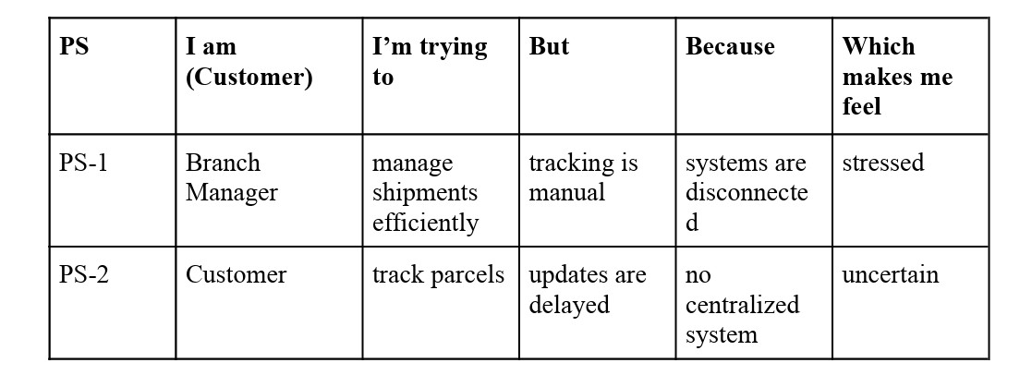
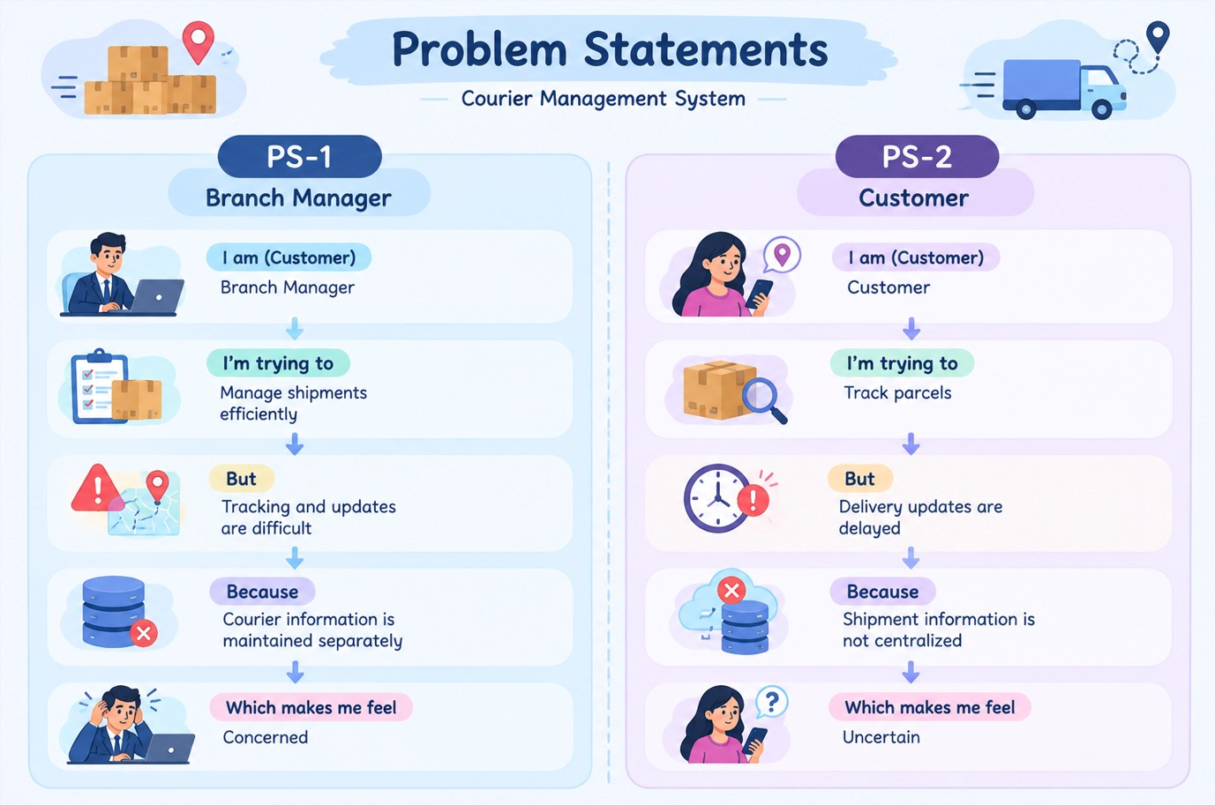

2.2 Empathy Map Canvas

User Persona: Branch Manager
- Think & Feel: Wants to manage shipments accurately and avoid delivery delays.
- Hear: Receives customer enquiries about shipment and delivery status.
- See: Customer, Shipment, Delivery Agent and Delivery Update records.
- Say & Do: Checks shipment details, assigns agents and monitors delivery updates.
- Pain & Gain: Faces difficulty with separate information; needs connected records and quick status updates.
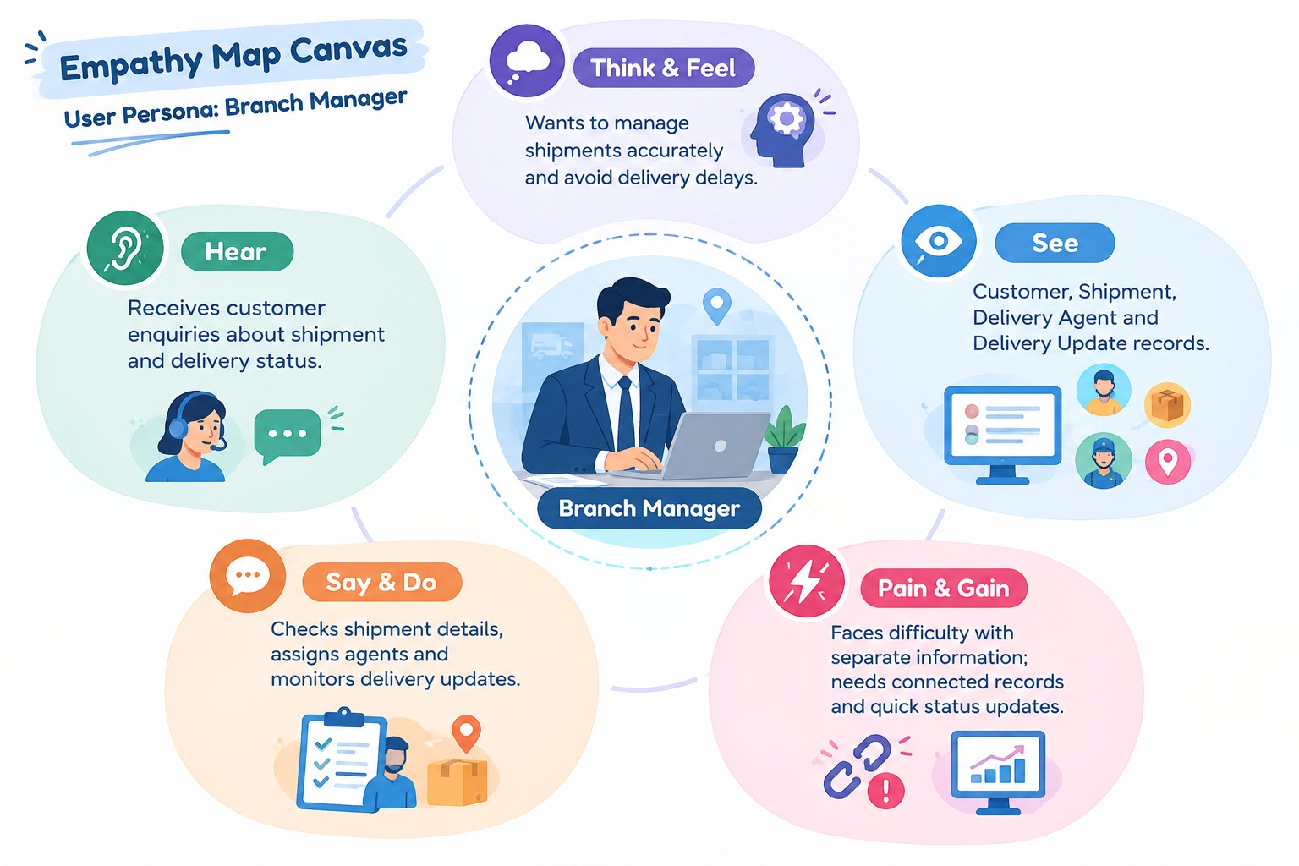

2.3 Brainstorming & Idea

Prioritization Ideas Considered
- Manual register-based courier tracking
- Spreadsheet-based shipment management
- Separate courier tracking application
- Salesforce-based Courier Management System

Final Selection
- Salesforce Objects for centralized data management
- Salesforce Flows for process automation
- Reports and Dashboards for monitoring courier operations

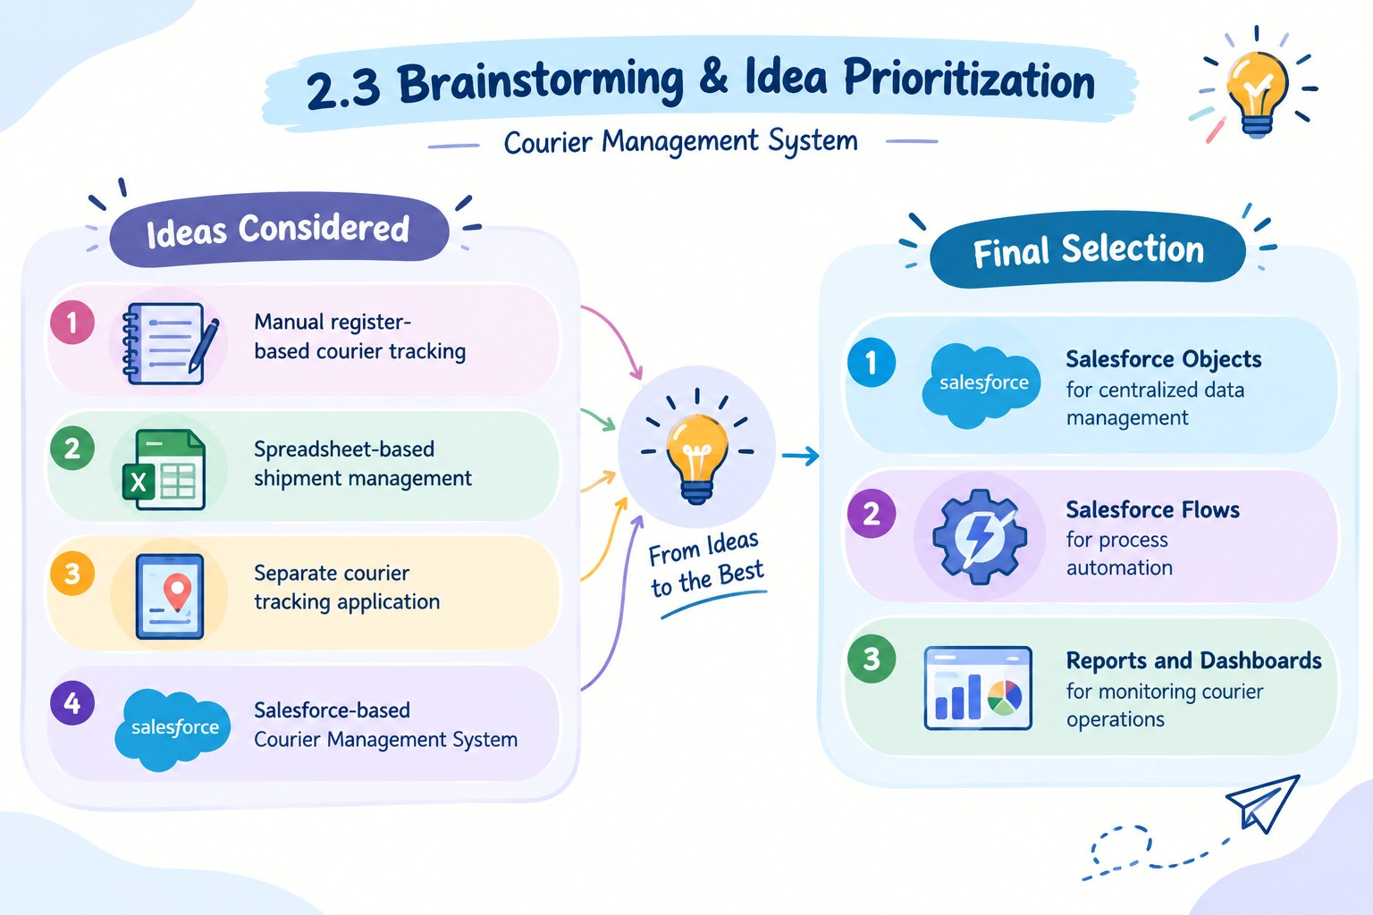

3.REQUIREMENT ANALYSIS PHASE

3.1 Customer Journey Map
Booking → Shipment Creation → Agent Assignment →
Transit → Delivery Update → Invoice → Reporting
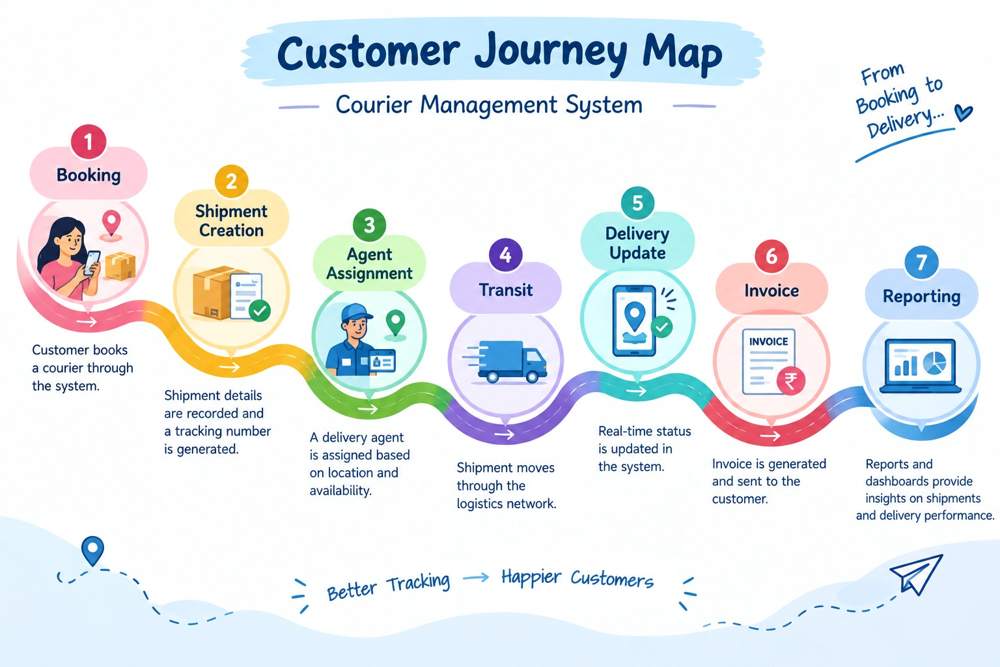

3.2 Solution Requirements
Functional Requirements
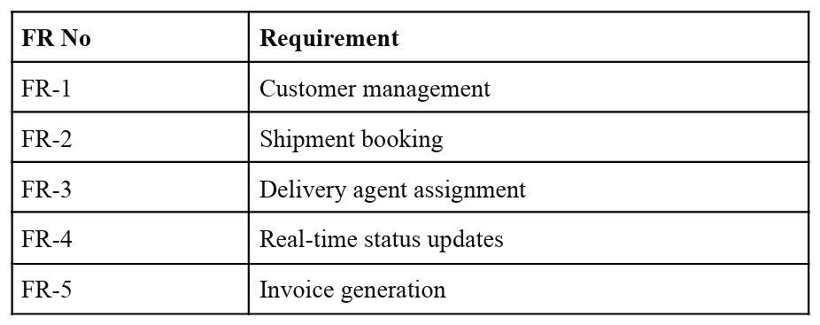

Non-Functional Requirements

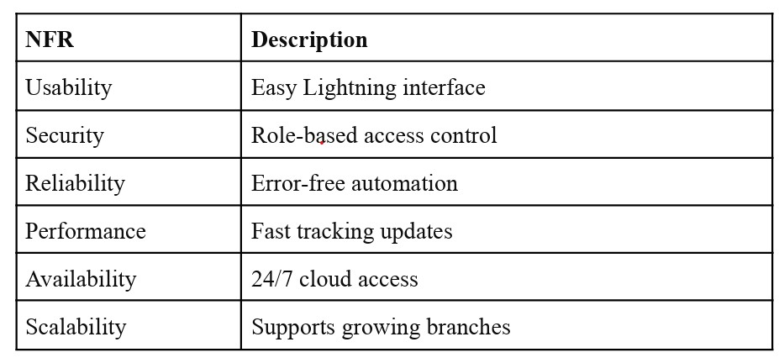

3.3 Data Flow Diagram

Flow:
Customer Input → Shipment Creation → Data Validation → Agent Assignment → Delivery Update → Invoice Generation → Reports & Dashboards.

3.4 Technology Stack
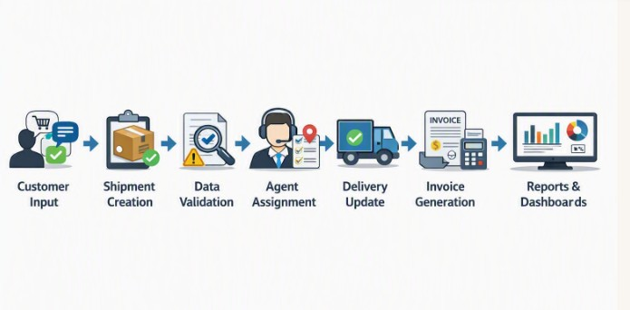

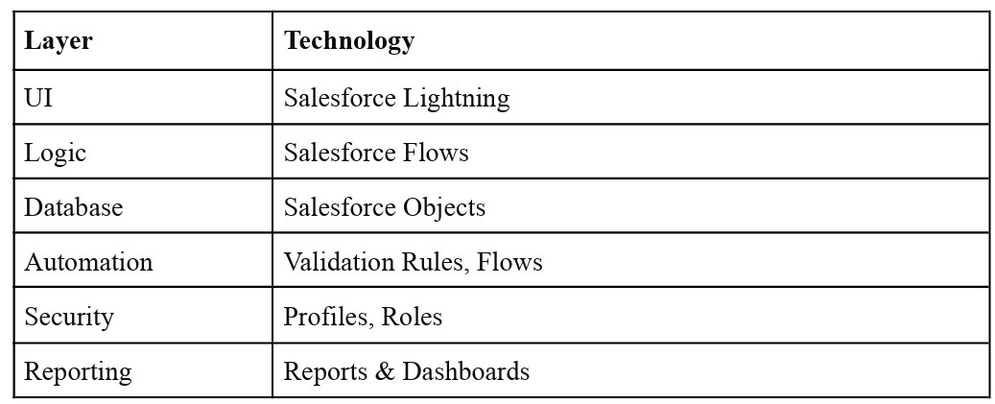

4. PROJECT DESIGN PHASE
4.1 Problem–Solution Fit
The system solves the difficulty of managing courier information separately.Salesforce provides a centralized platform to manage customer and shipment records.Flows and Validation Rules help automate processes and maintain accurate data.Reports and Dashboards help monitor courier activities efficiently.

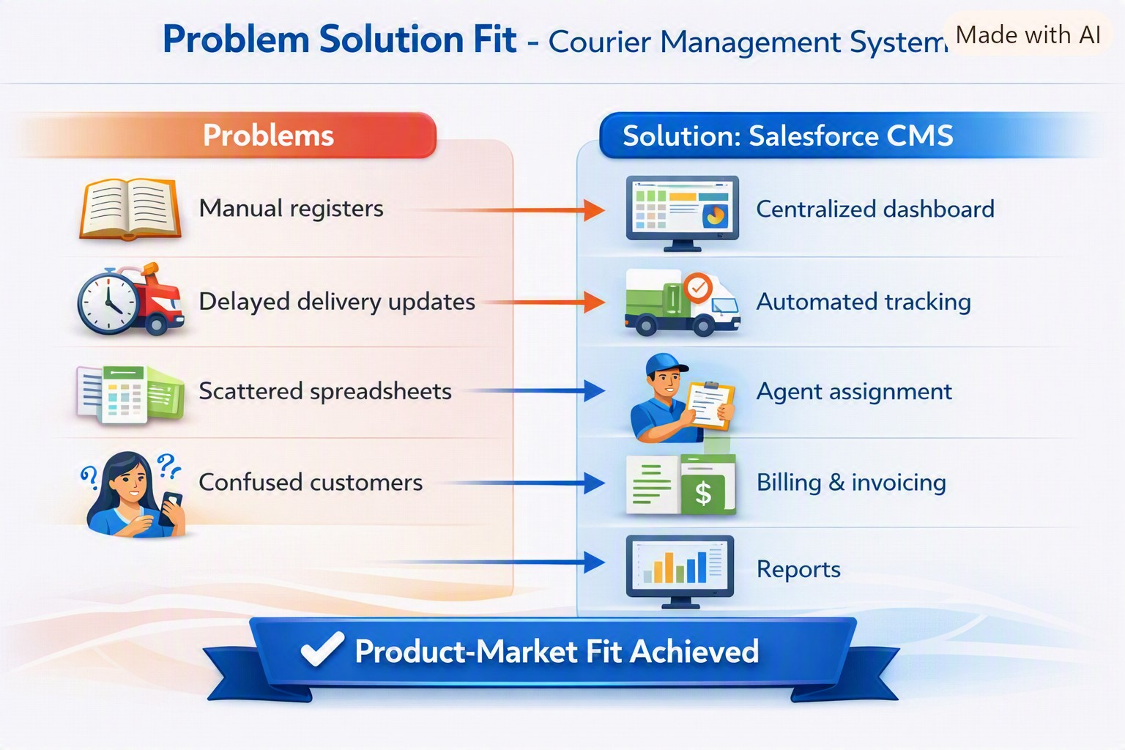

4.2 Proposed Solution

Functional Requirements
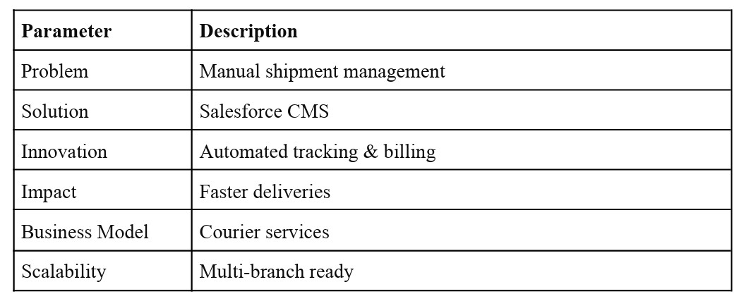

4.3 Solution Architecture

Components:

- Customer Object – Stores customer details and contact information.

- Shipment Object – Maintains shipment and tracking information.

- Delivery Agent & Branch Objects – Manage agent assignments and branch details.

- Delivery Update & Invoice Objects – Maintain delivery status and billing details.

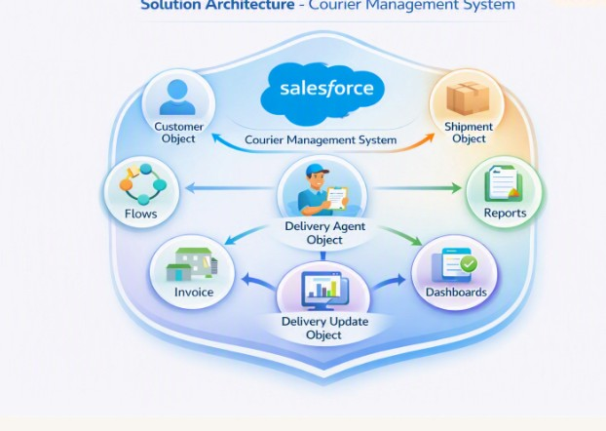

5. PROJECT PLANNING & SCHEDULING

5.1 Project Planning

Requirement Planning – Identify the required courier operations and system features.
Design Planning – Plan the objects, fields, relationships, and overall system structure.
Development Planning – Configure Salesforce components and automation according to the requirements.
Testing & Documentation – Test the system functions and prepare the final project documentation.

Product Backlog, Sprint Schedule, and Estimation (4 Marks)
Use the below template to create product backlog and sprint schedule
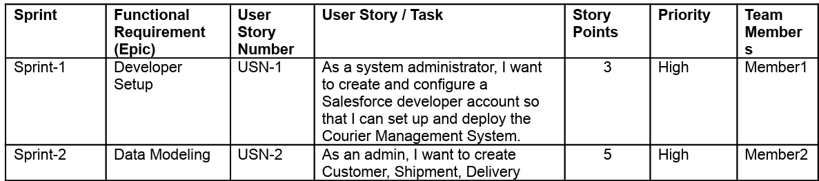
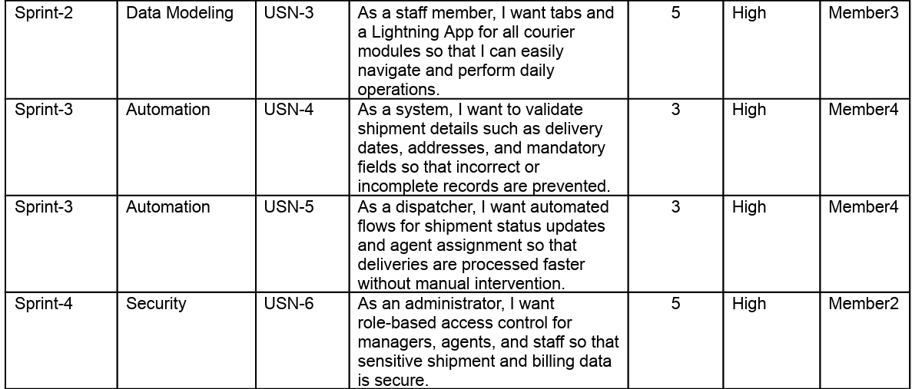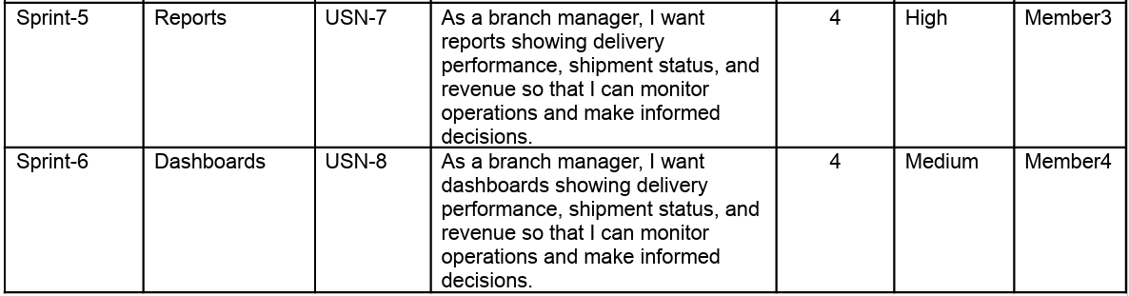

Project Tracker, Velocity & Burndown Chart (4 Marks)
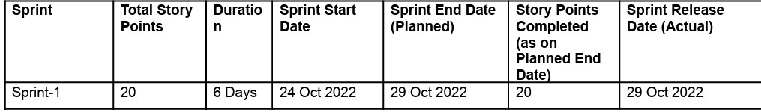

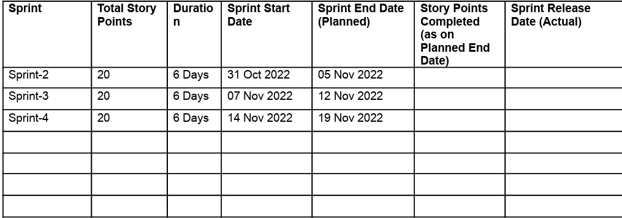

6. Project Development Phase: What You'll Learn
- Creating and configuring Salesforce Objects and Fields.
- Establishing Relationships between courier records.
- Creating Validation Rules for accurate data entry.
- Building Flows to automate shipment status updates.
- Configuring Profiles, Roles, Reports, and Dashboards.

Milestone 1: Salesforce Account
Introduction:
Salesforce Account setup provides the basic environment required to develop and manage the Courier Management System.
What is Salesforce?
Salesforce is a cloud-based CRM (Customer Relationship
Management) platform used to store, manage, and organize business data. It provides tools such as Objects, Fields, Flows, Reports, Dashboards, Profiles, and Roles to build and manage applications like the Courier Management System.

Activity 1: Creating Developer Account
Creating a developer org in salesforce.
- Go to https://developer.salesforce.com/signup
- On the sign up form, enter the following details :
- First name & Last name
- Email
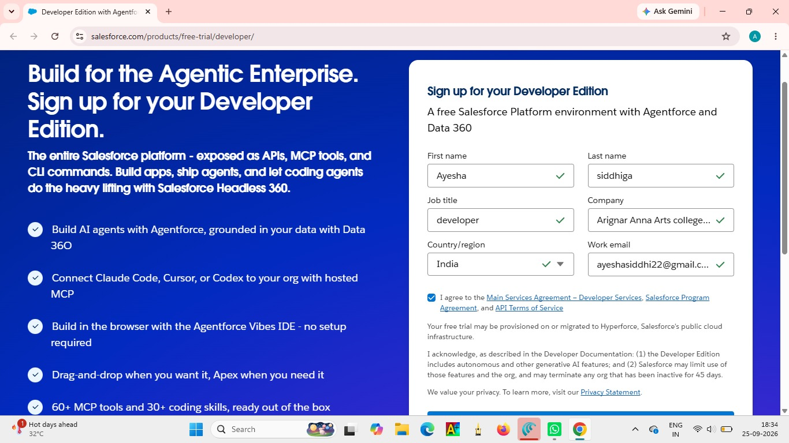

- First name: Ayesha & Last name: Siddhiga
- Email: ayeshasiddhi22@gmail.com

- Job Title: Developer
- Company: Arignar Anna Govt Arts College For Women,Walajapet.
- Country: India
Click on sign me up after filling these.

Activity 2: Account Activation
- Go to the inbox of the email that you used while signing up. Click on the verify account to activate your account. The email may take
  - ins and sometimes 2 hours

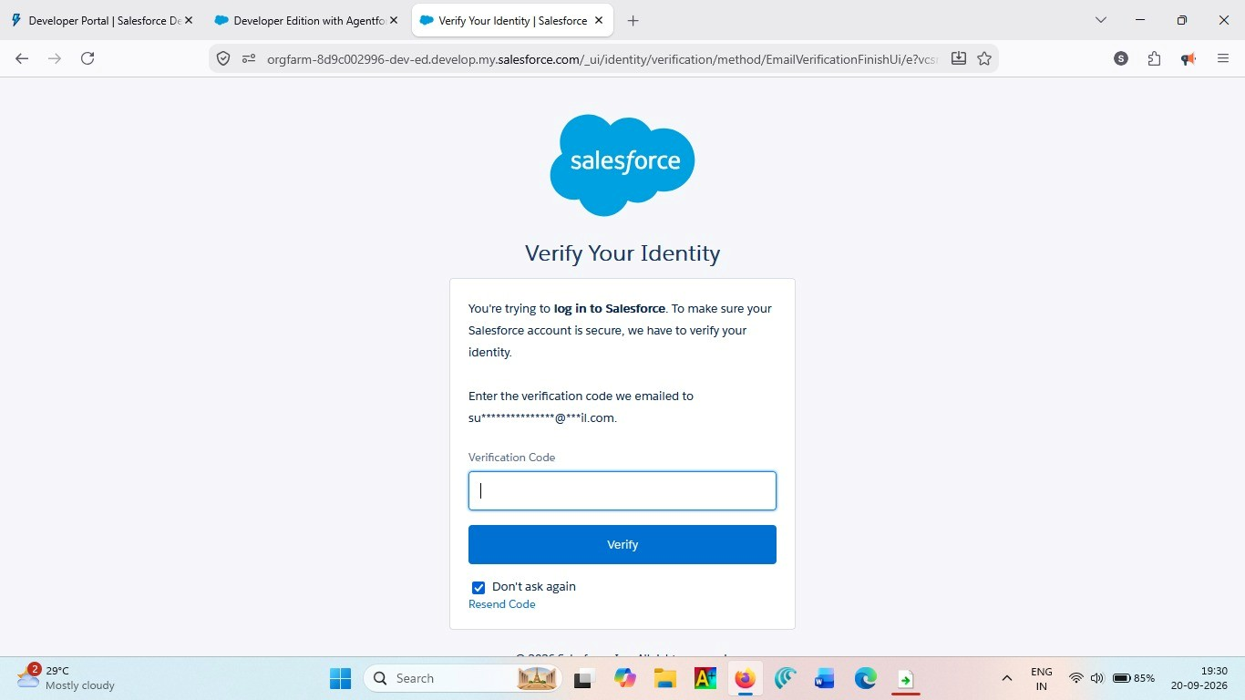
2.Click on Verify Account
3.Give a password and answer a security question and click on change password.
4.Then you will redirect to your salesforce setup page.
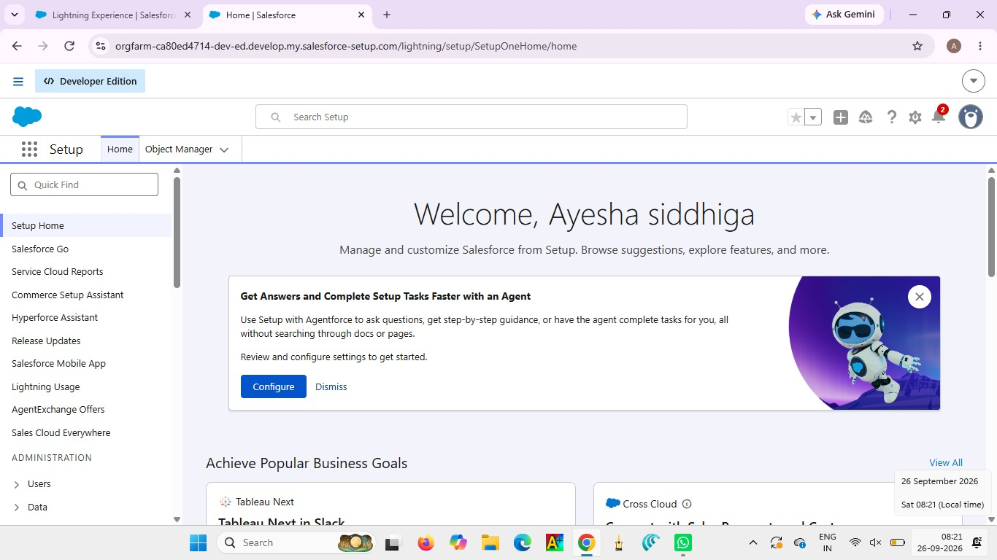

Milestone 2- Object:
What is an object?
A Salesforce Object is a structure used to store and organize related data in the Salesforce platform. In the Courier Management
System, objects are used to maintain details such as Customer, Shipment, Delivery Agent, Branch, Delivery Update, and Invoice.
Relationships:
Relationships in Salesforce are used to connect different objects and link related records. In the Courier Management System, they connect Customer, Shipment, Delivery Agent, Branch, Delivery Update, and Invoice records.

Steps to Implement :
Activity 1:
- Create Customer Object 1. Click Setup → Object Manager → Create → Custom Object

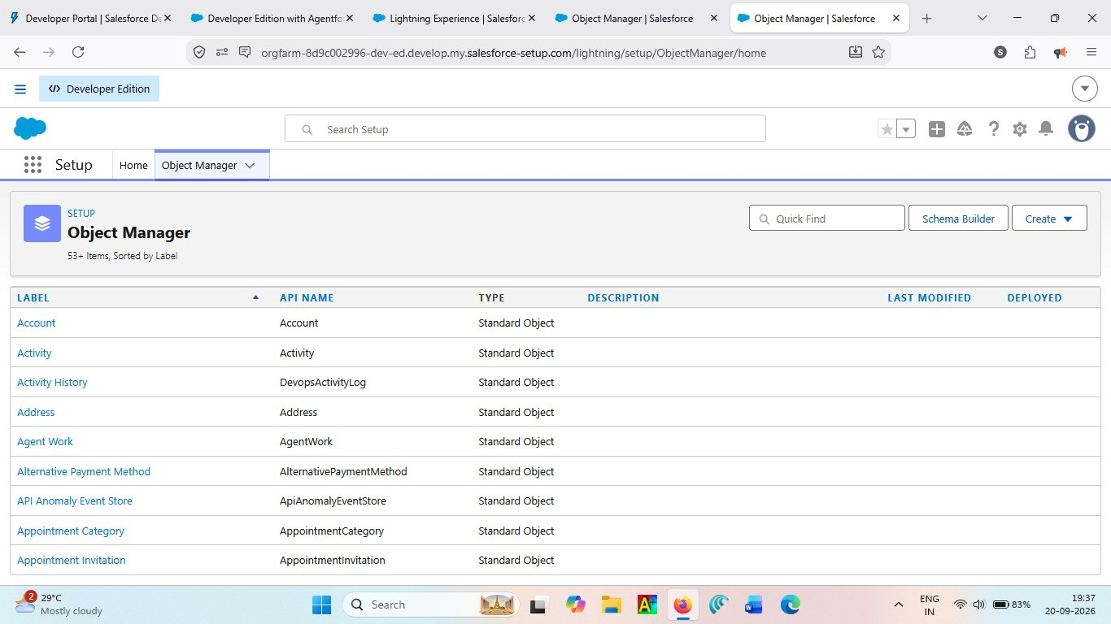

- Enter the following details:
  - Label: Customer
  - Plural Label: Customers
  - Record Name: Customer Name (Text)
- Under Optional Features:
  - Enable Allow Reports
  - Enable Track Field History
  - In Search Status check the box Allow Search
  - In Object Creation Options check the box Add Notes and
Attachments related list to default page layout
4. Click Save.
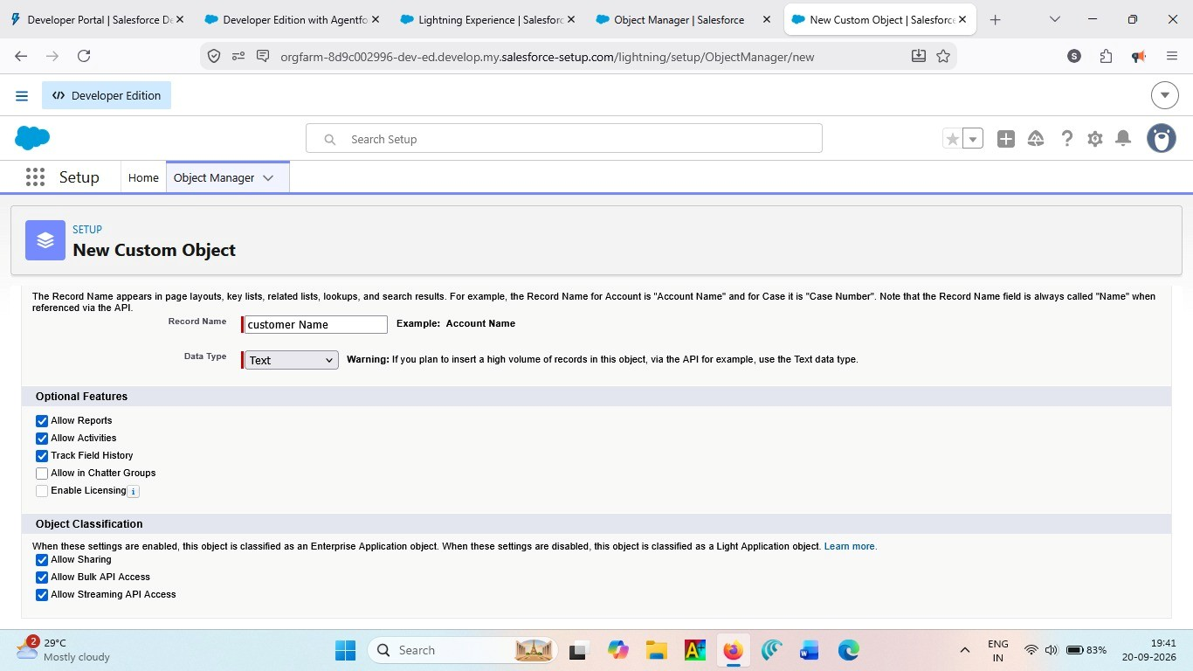

Activity 2:

Create Shipment Object
- Go to Setup → Object Manager → Create → Custom Object
- Enter:
- Label: Shipment
- Plural Label: Shipments
- Record Name: Tracking Number (Auto Number)
- Example Format: SHP-{00000}
Starting Number: 0
- Enable:
- Allow Reports
- Track Field History
5. Click Save
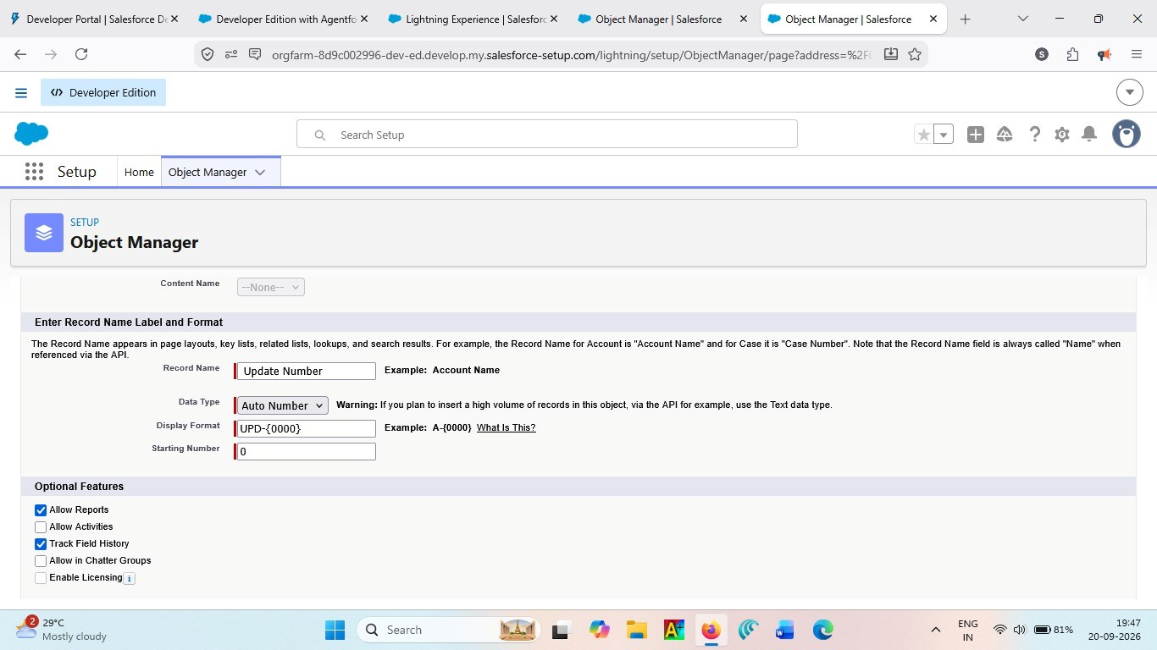

Activity 3: Create Delivery_Agent Object
- Setup → Object Manager → Create → Custom Object
- Enter:
- Label: Delivery Agent
- Plural Label: Delivery Agents
- Record Name: Agent Name (Text) 3. Enable:
- Allow Reports
- Track Field History
4. Click Save
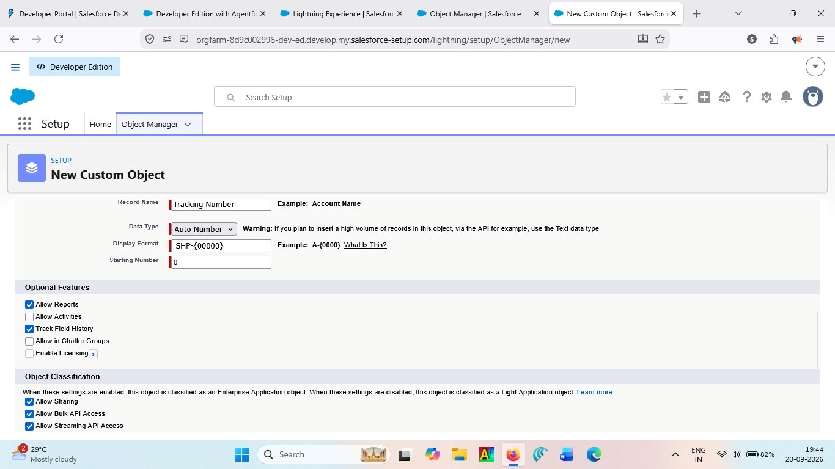

Activity 4: Create Branch Object
- Setup → Object Manager → Create → Custom Object
- Enter:
- Label: Branch
- Plural Label: Branches
- Record Name: Branch Name (Text)
3. Enable:
● Allow Reports
4. Click Save.
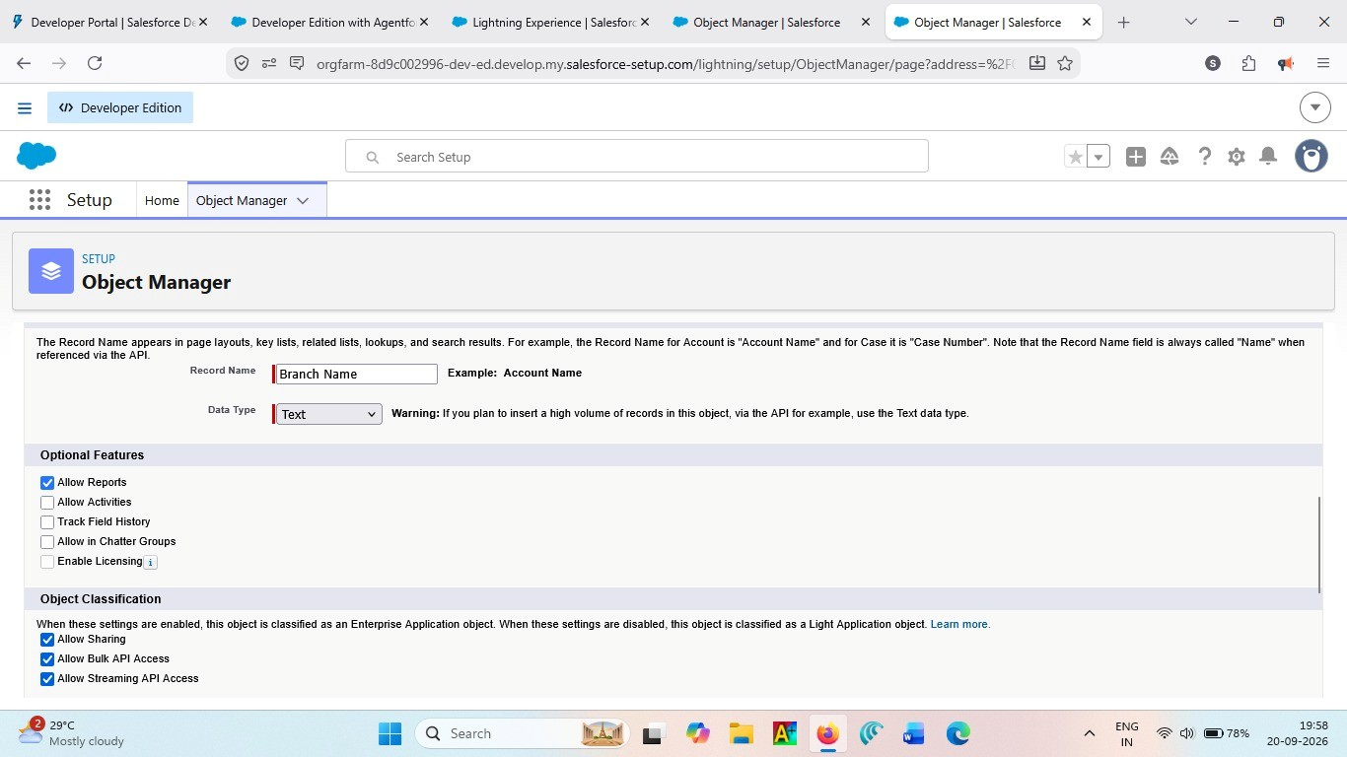

Activity 5: Create Delivery_Update Object
- Setup → Object Manager → Create → Custom Object
- Enter:
- Label: Delivery Update
- Plural Label: Delivery Updates
- Record Name: Update Number (Auto Number) 3. Example Format: UPD-{0000} Enter Starting number : 0
4.Enable:
- Allow Reports
- Track Field History
5. Click Save.
Activity 6:

Create Invoice Object
- Setup → Object Manager → Create → Custom Object
- Enter:
- Label: Invoice
- Plural Label: Invoices
- Record Name: Invoice Number (Auto Number) 3. Example Format: INV-{0000} Enter Starting number: 0
4. Enable:
- Allow Reports
- Track Field History
5. Click Save
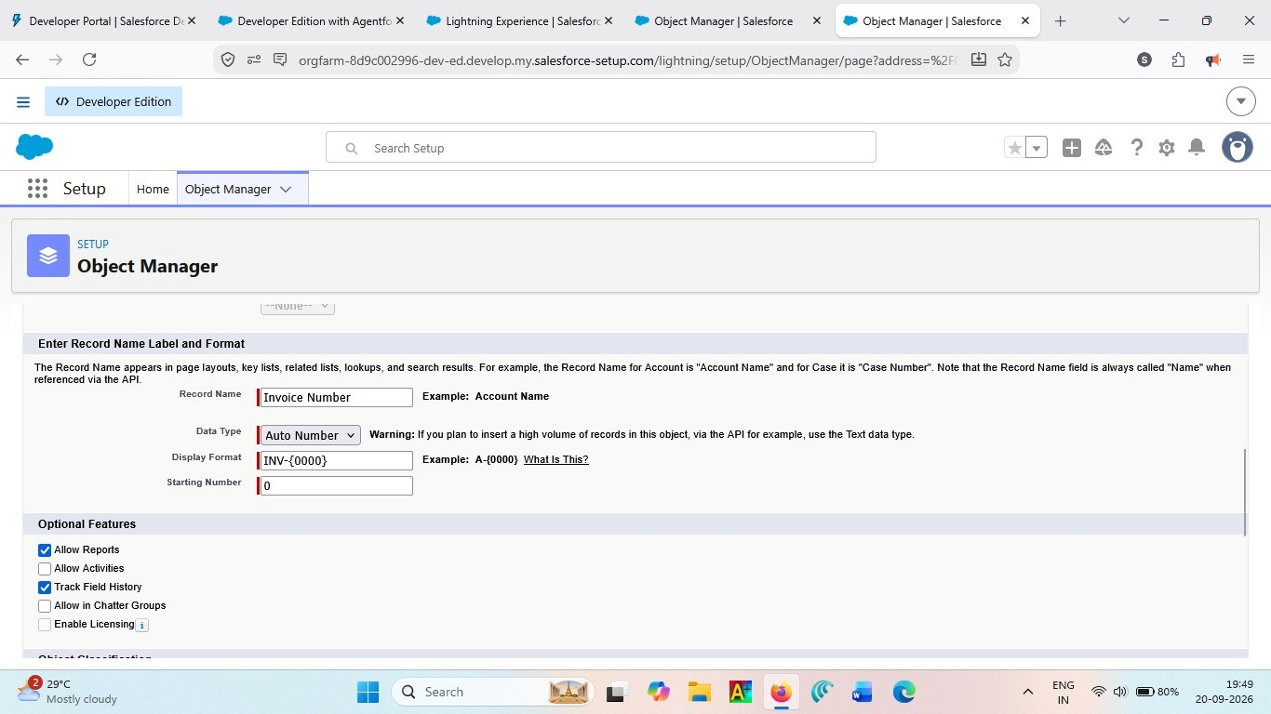

Milestone 3 - Tabs
Tab:

Salesforce Tabs provide easy access to the different modules of the Courier Management System, such as Customer, Shipment, Delivery Agent, Branch, Delivery Update, and Invoice.

Activity 1: Creating a Tab for Customer Object
- Click Home, type Tabs in Quick Find, and select Tabs.
- Under Custom Object Tabs, click New.
- For Object, select Customer.
- For Tab Style, choose any icon.
- Leave all default settings as they are.
- Click Next, Next, and Save.
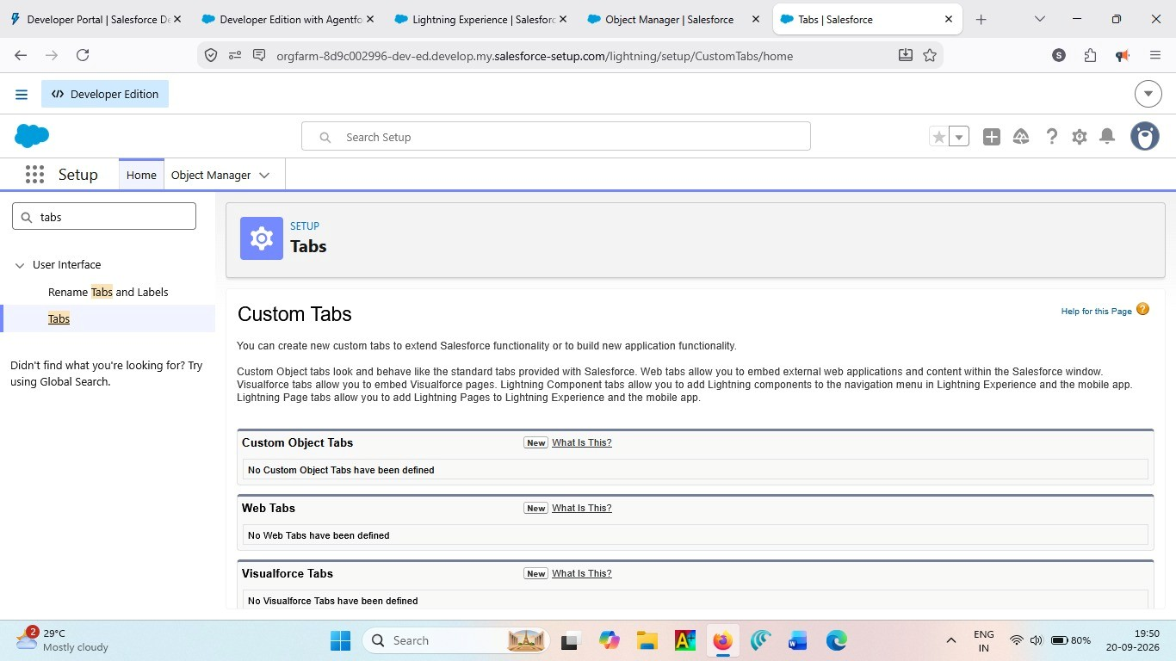

Activity 2: Creating a Tab for Shipment Object
- Click Home, type Tabs in Quick Find, and select Tabs.
- Under Custom Object Tabs, click New.
- For Object, select Shipment.
- Choose any Tab Style.
- Keep defaults unchanged.
- Click Next, Next, and Save.
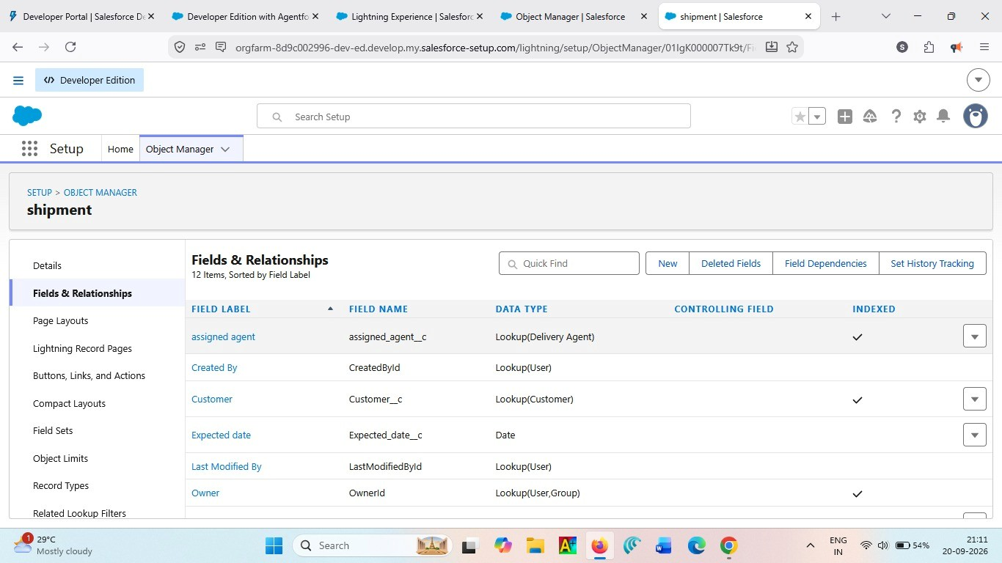

Activity 3: Creating a Tab for Delivery Agent Object
- Click Home, type Tabs in Quick Find, and select Tabs.
- Under Custom Object Tabs, click New.
- For Object, select Delivery Agent.
- Pick any Tab Style.
- Leave default settings.
- Click Next, Next, and Save.
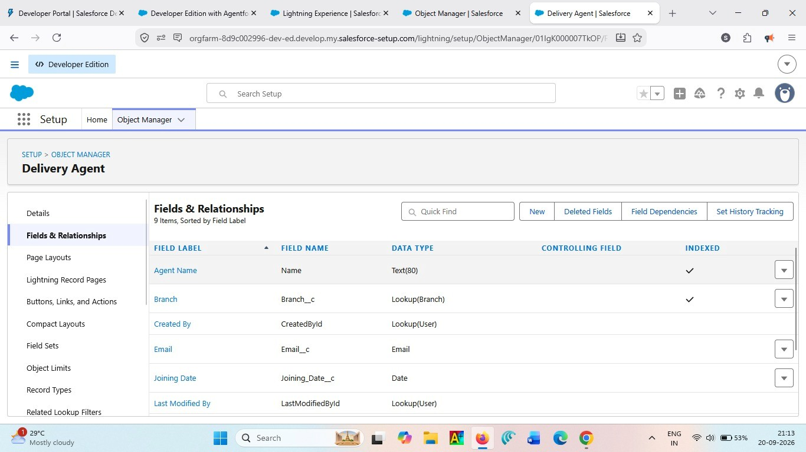

Activity 4: Creating a Tab for Branch Object
- Click Home, type Tabs in Quick Find, and select Tabs.
- Under Custom Object Tabs, click New.
- For Object, select Branch.
- Choose any Tab Style.
- Keep all defaults.
- Click Next, Next, and Save.
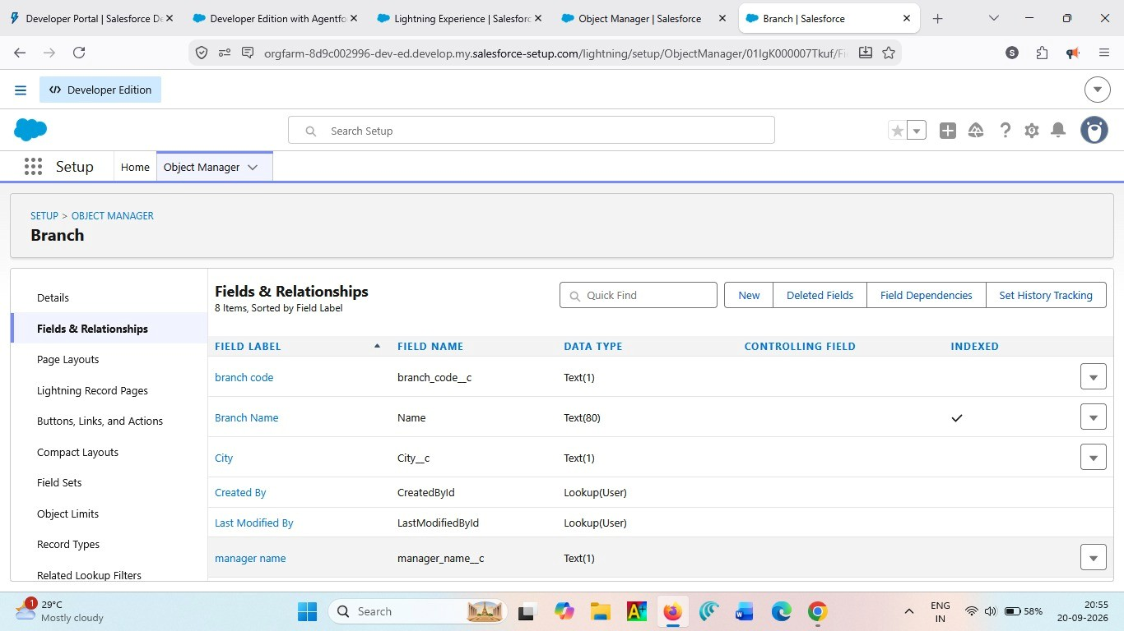

Activity 5: Creating a Tab for Delivery Update Object
- Click Home, type Tabs in Quick Find, and select Tabs.
- Under Custom Object Tabs, click New.
- For Object, select Delivery Update.
- Select any Tab Style.
- Keep default configurations.
- Click Next, Next, and Save.
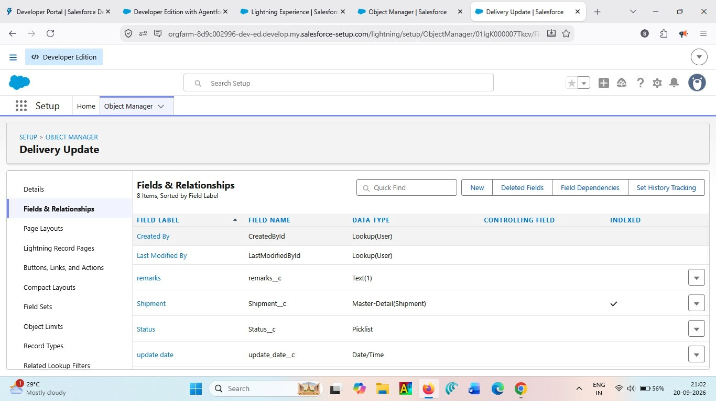

Activity 6: Creating a Tab for Invoice Object
- Click Home, type Tabs in Quick Find, and select Tabs.
- Under Custom Object Tabs, click New.
- For Object, select Invoice.
- Select any Tab Style.
- Leave defaults unchanged.
- Click Next, Next, and Save.
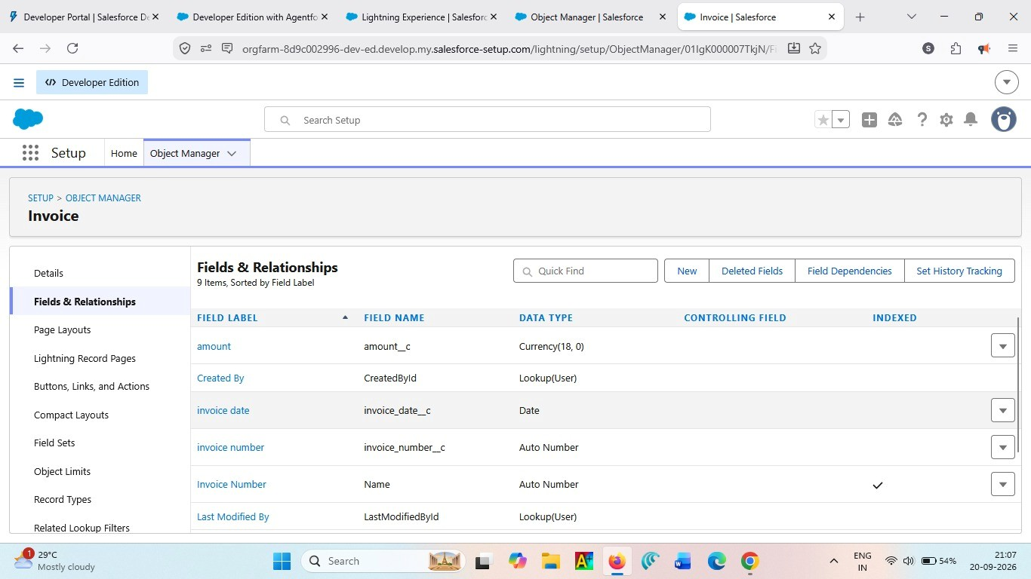
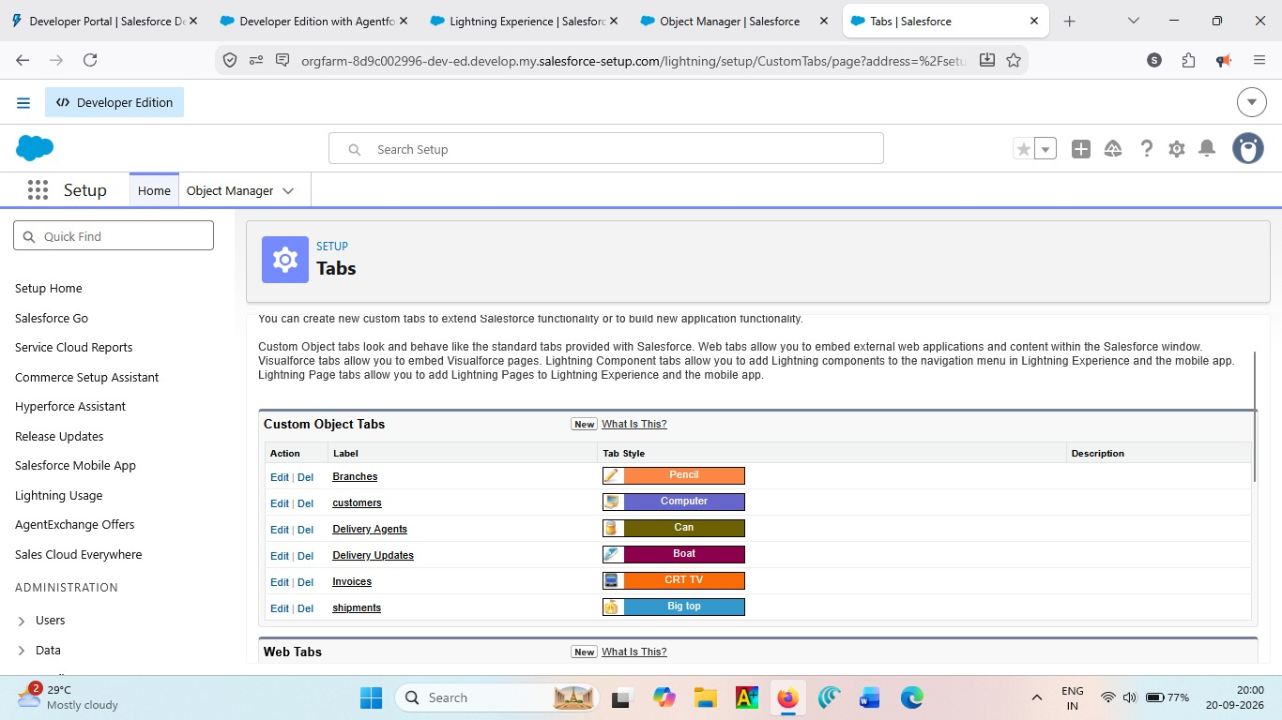

Milestone 4: Fields & Relationships
What are fields ?
Fields are used to store specific information within a Salesforce object. They define the data maintained for each record, such as Customer Name, Phone, Tracking Number, Shipment Status, Weight, and Price in the Courier Management System.

Activity 1: Creation of fields for the Customer Object
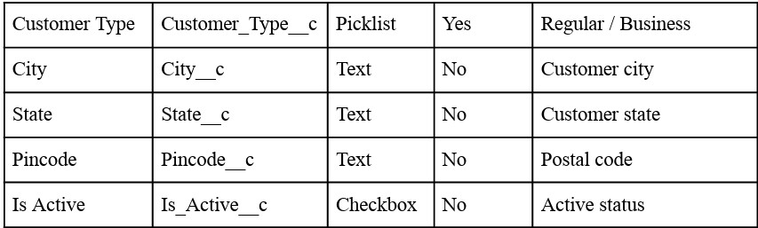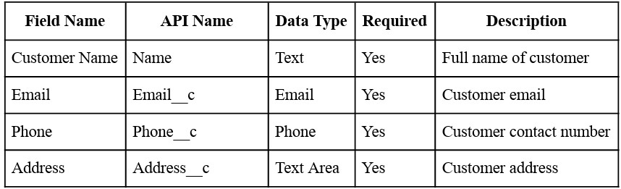

1. Email (Email Field)
- Go to Setup → Object Manager → Customer__c
- Click Fields & Relationships → New
- Select Email → Next
- Field Label: Email
- Check the Required box
- Click Next → Next → Save
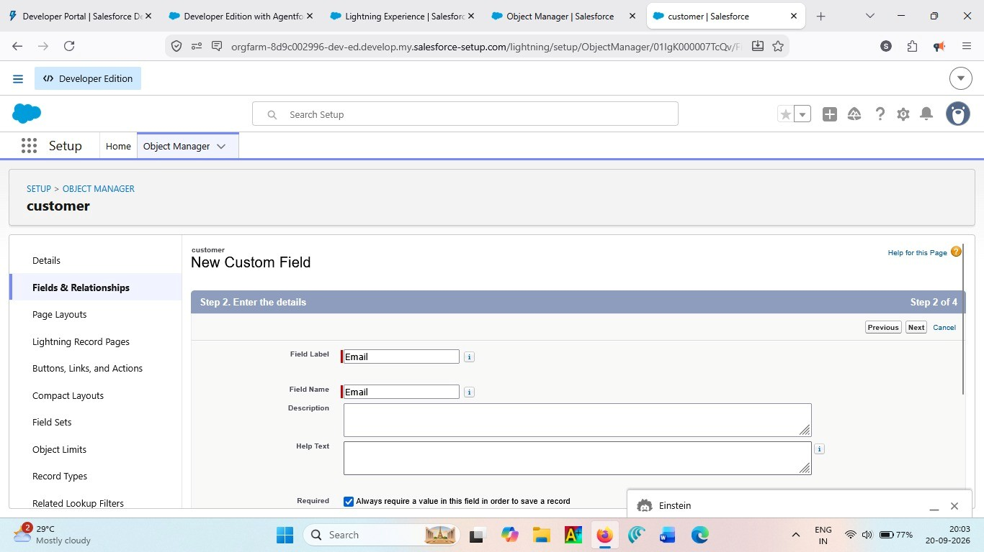

2. Phone (Phone Field)
- Setup → Object Manager → Customer__c
- Fields & Relationships → New
- Select Phone → Next
- Field Label: Phone
- Check Required
- Click Next → Next → Save
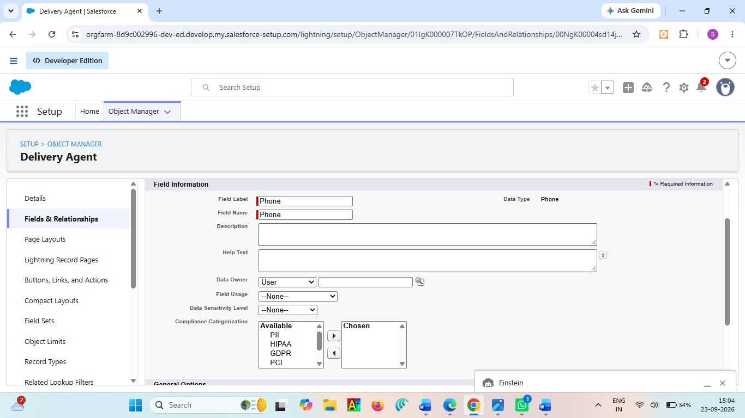

3. Address (Text Area)
- Setup → Object Manager → Customer__c Regular / Business Customer city Customer state Postal code Active status
- Fields & Relationships → New
- Select Textarea → Next
- Field Label: Address
- Check Required
- Save
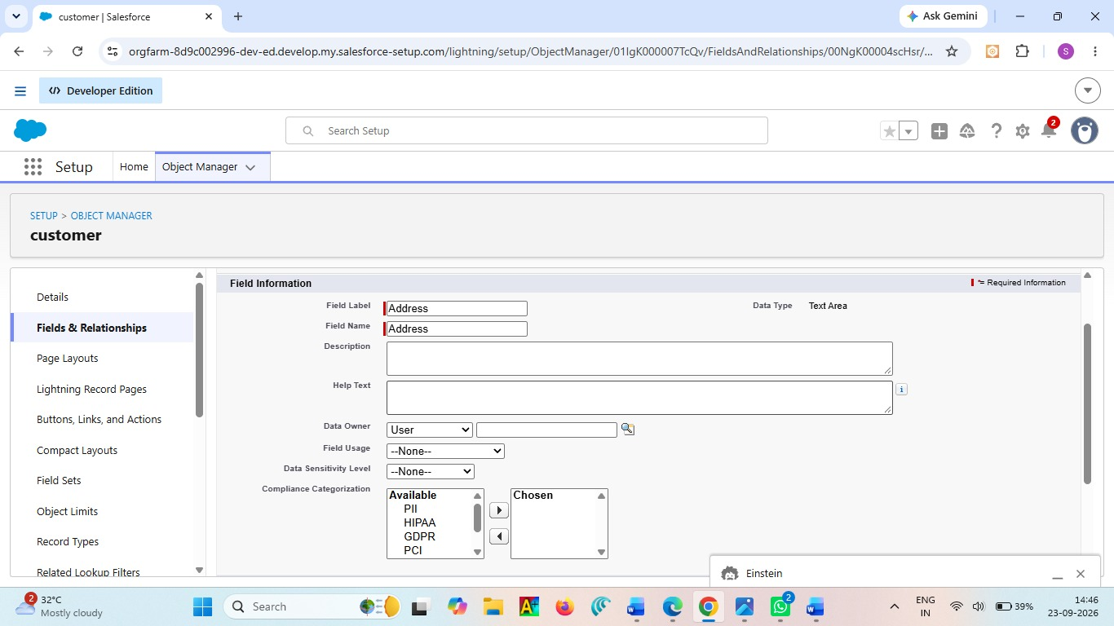

4. Customer Type (Picklist)
- Setup → Customer__c → Fields → New
- Picklist → Next
- Field Label: Customer Type
- Enter values:
○ Regular
○ Business
- Check Required
- Save
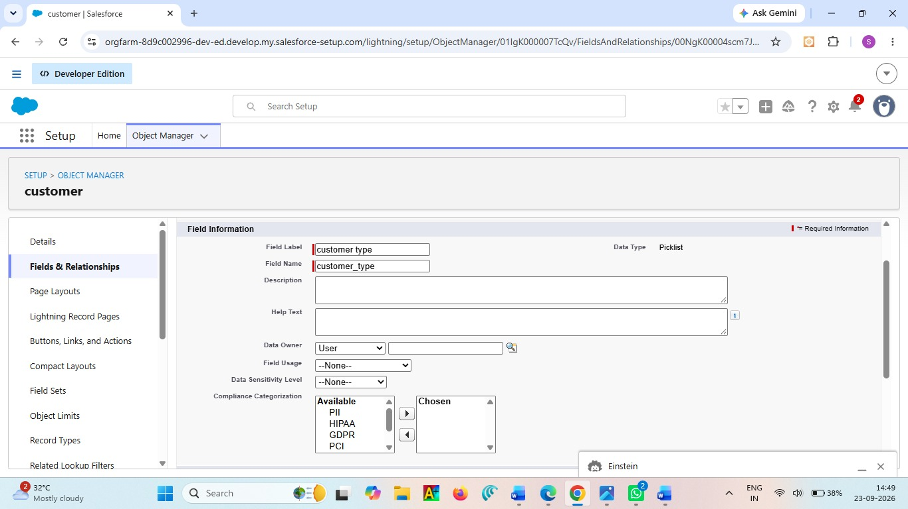

5. City (Text)
- Setup → Customer__c → Fields → New
- Text → Next
- Field Label: City
- Save
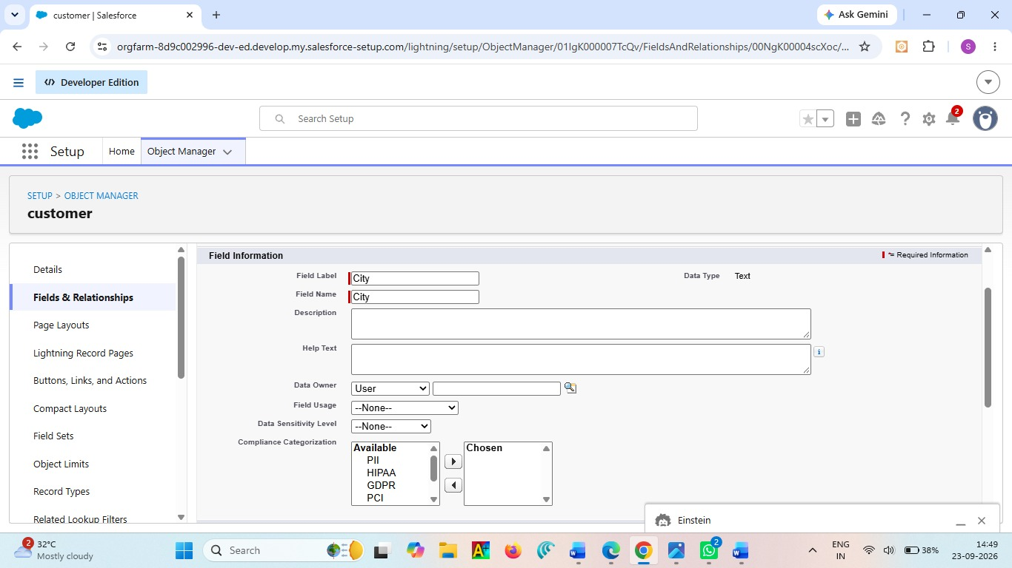

6. State (Text)
- Setup → Customer__c → Fields → New
- Text → Next
- Field Label: State
- Save
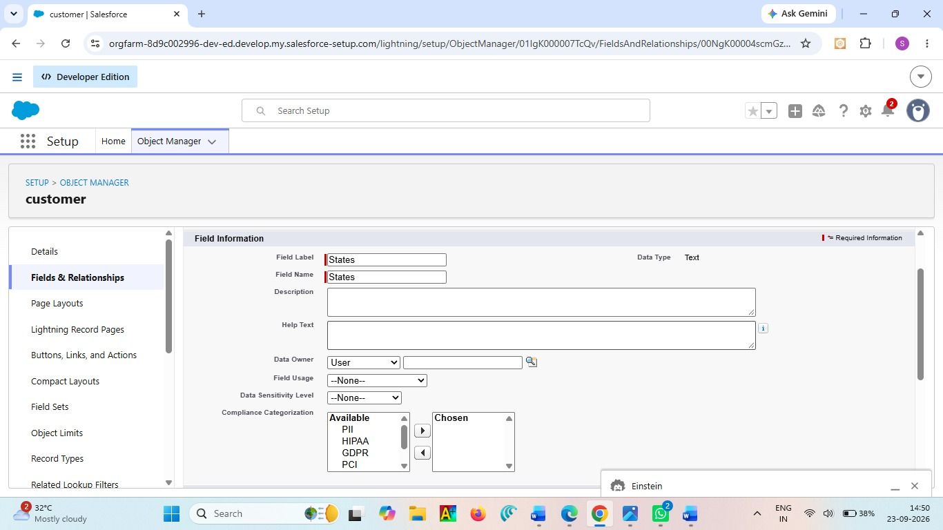

7. Pincode (Text)
- Setup → Customer__c → Fields → New
- Text → Next
- Field Label: Pincode
- Save
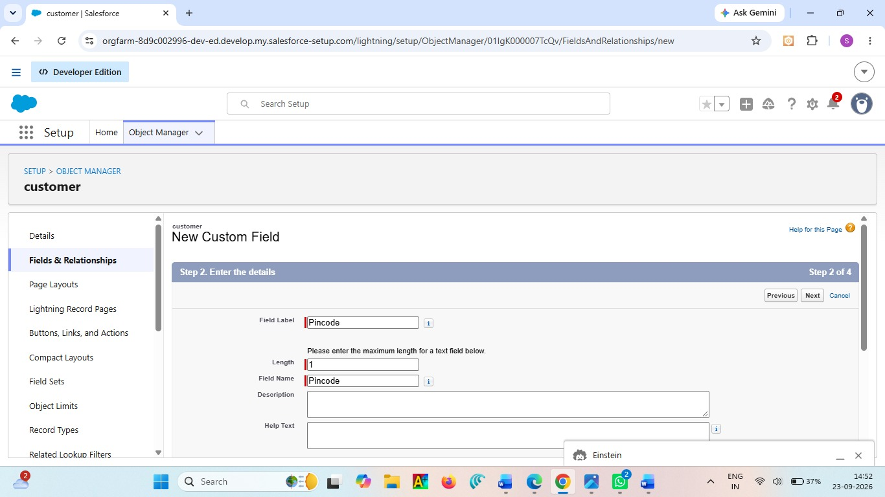

8. Is Active (Checkbox)
- Setup → Customer__c → Fields → New
- Checkbox → Next
- Field Label: Is Active
- Save
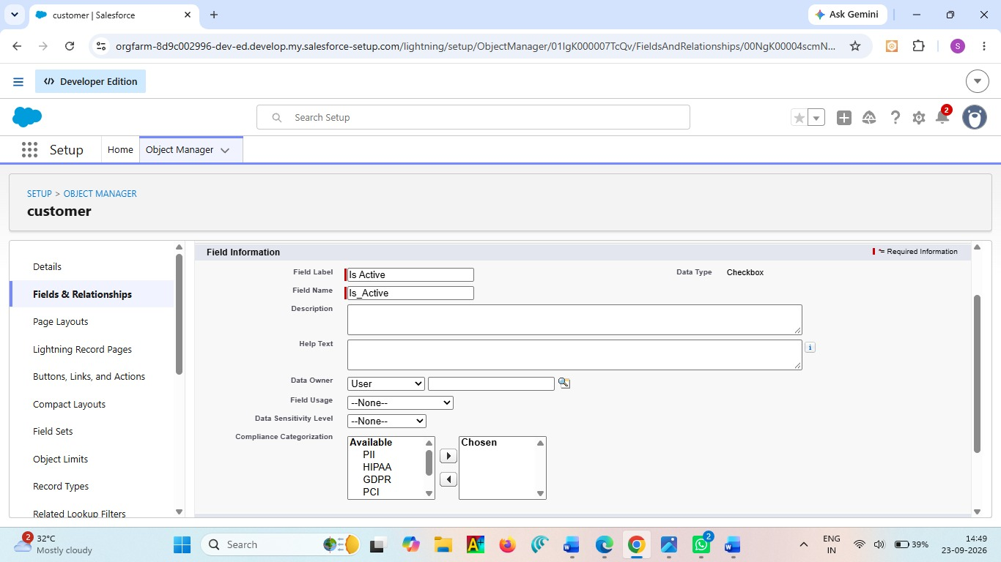

Activity 2: Creation of fields for the Shipment Object

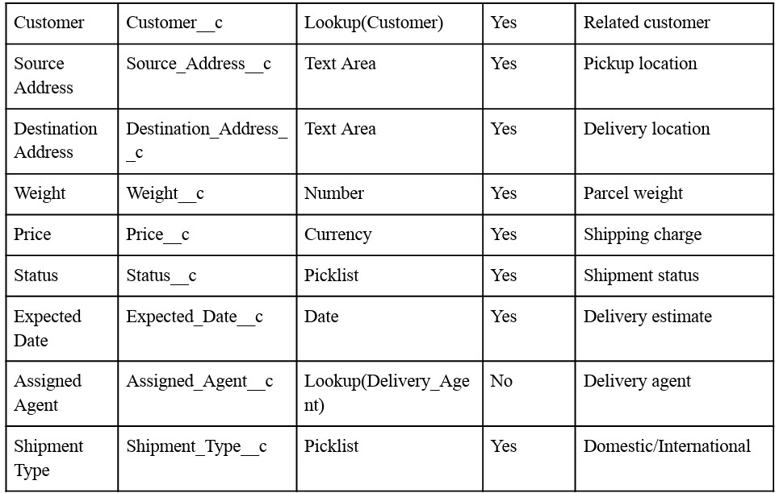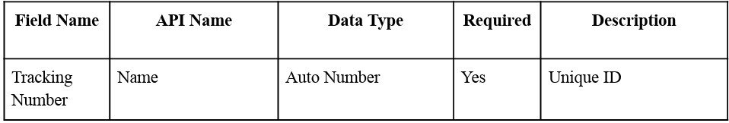

1. Source Address (Text Area)
- Setup → Shipment__c → Fields → New
- Textarea → Next
- Field Label: Source Address
- Required → Save

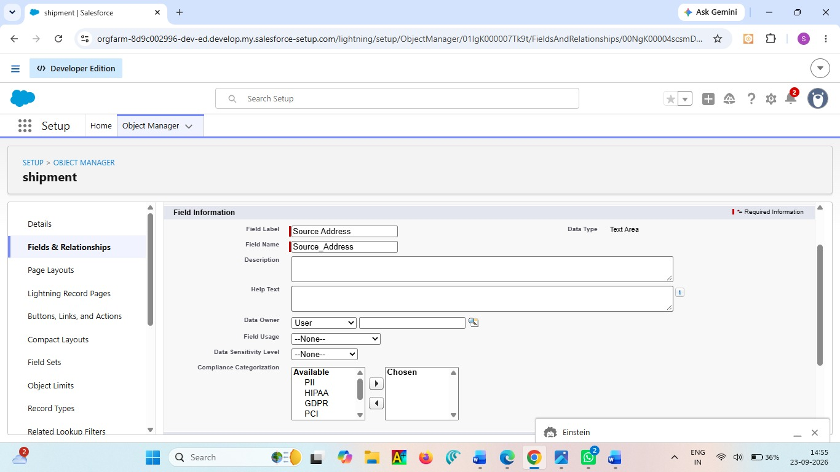

2. Destination Address (Text Area)
- Setup → Shipment__c → Fields → New
- Textarea → Next
- Field Label: Destination Address
- Required → Save

3. Weight (Number)
- Setup → Shipment__c → Fields → New
- Number → Next
- Field Label: Weight
- Required → Save
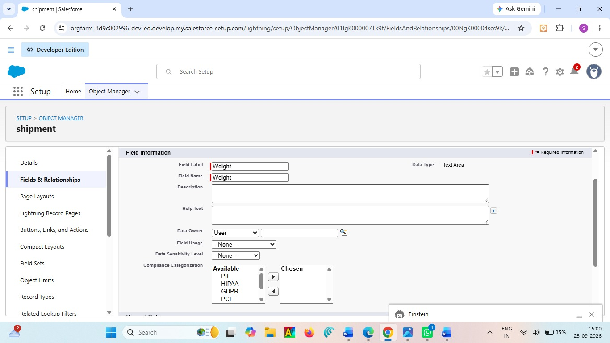

4. Price (Currency)
- Setup → Shipment__c → Fields → New
- Currency → Next
- Field Label: Price
- Required → Save 5. Status (Picklist) Values:
- Booked
- In Transit
- Out for Delivery
- Delivered
- Cancelled
Required → Save
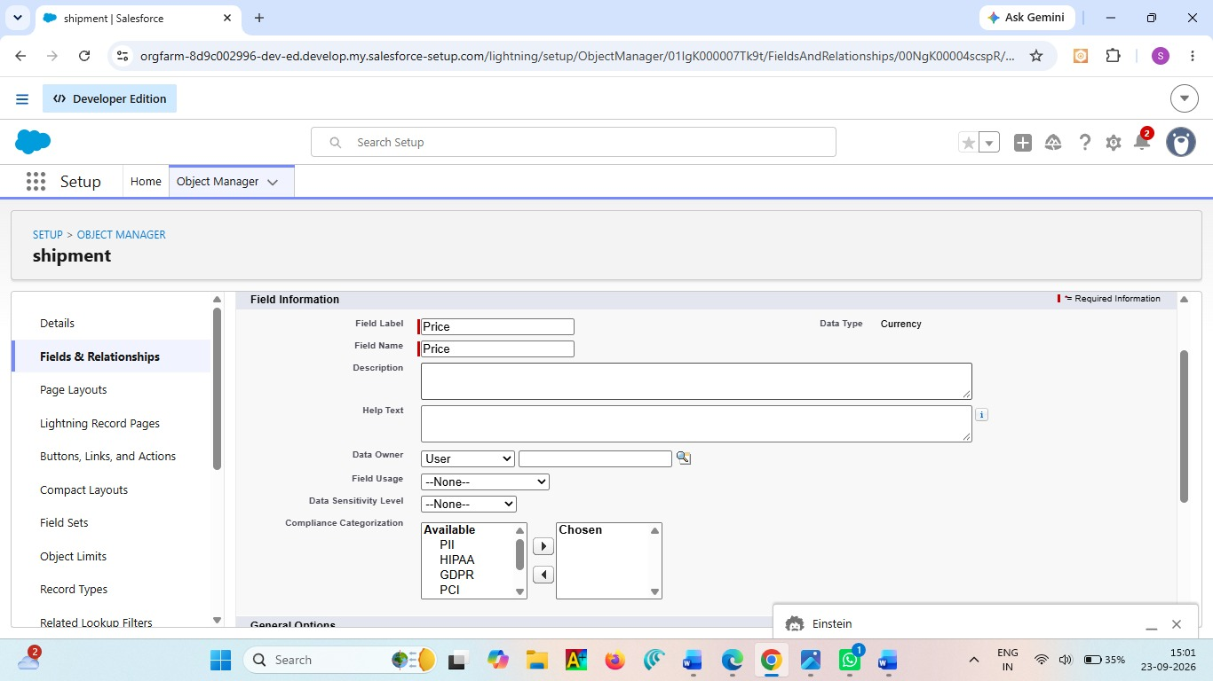

6. Expected Date (Date)
- Setup → Shipment__c → Fields → New
- Date → Next
- Field Label: Expected Date
- Required → Save
7. Shipment Type (Picklist) Values:
- Domestic
- International Required → Save
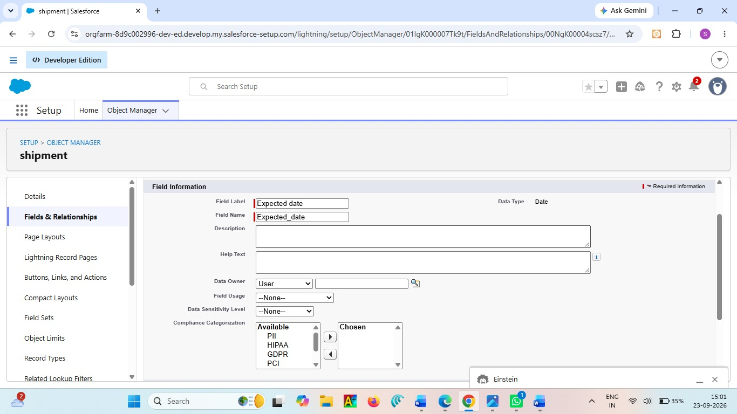

Activity 3: Creation of fields for Delivery_Agent Object
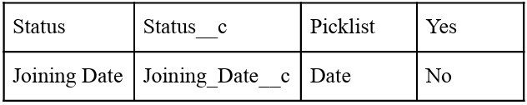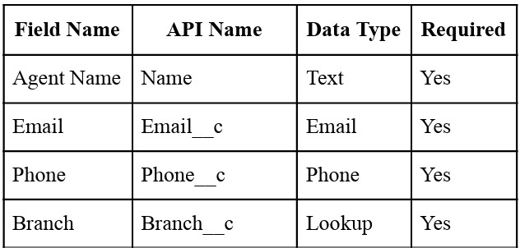

1. Email
- Setup → Delivery_Agent__c → Fields → New
- Email → Next
● Field Label: Email
- Required → Save
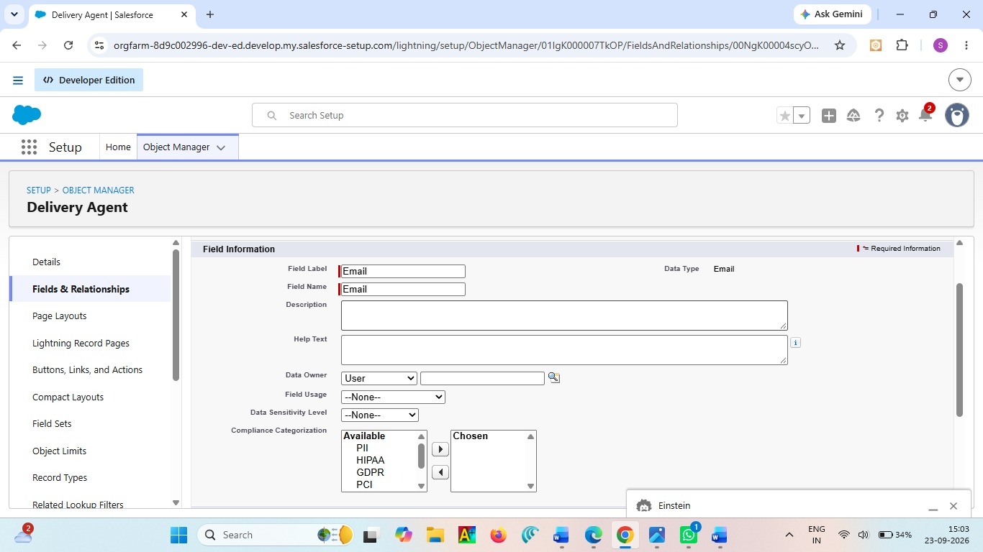

2. Phone
- Setup → Delivery_Agent__c → Fields → New
- Phone → Next
- Field Label: Phone
- Required → Save

3. Status (Picklist) Values:
- Active
- Inactive
- On Leave Required → Save
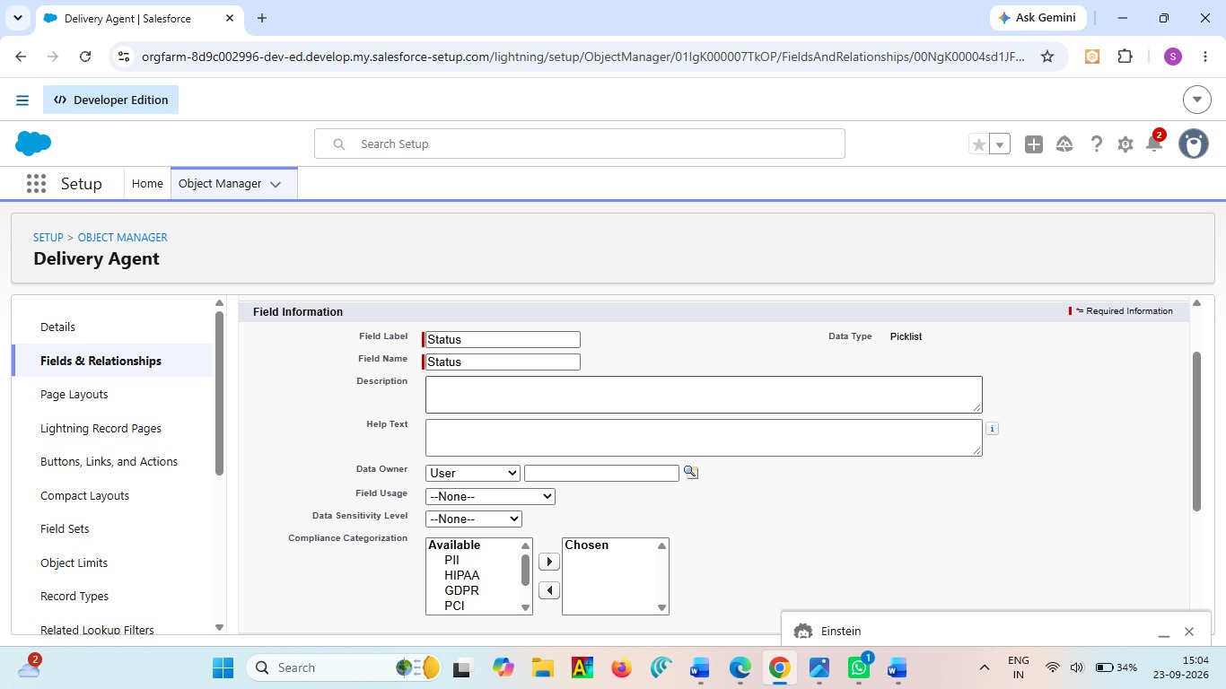

4. Joining Date
- Setup → Delivery_Agent__c → Fields → New
- Date → Next
- Field Label: Joining Date
- Save Activity
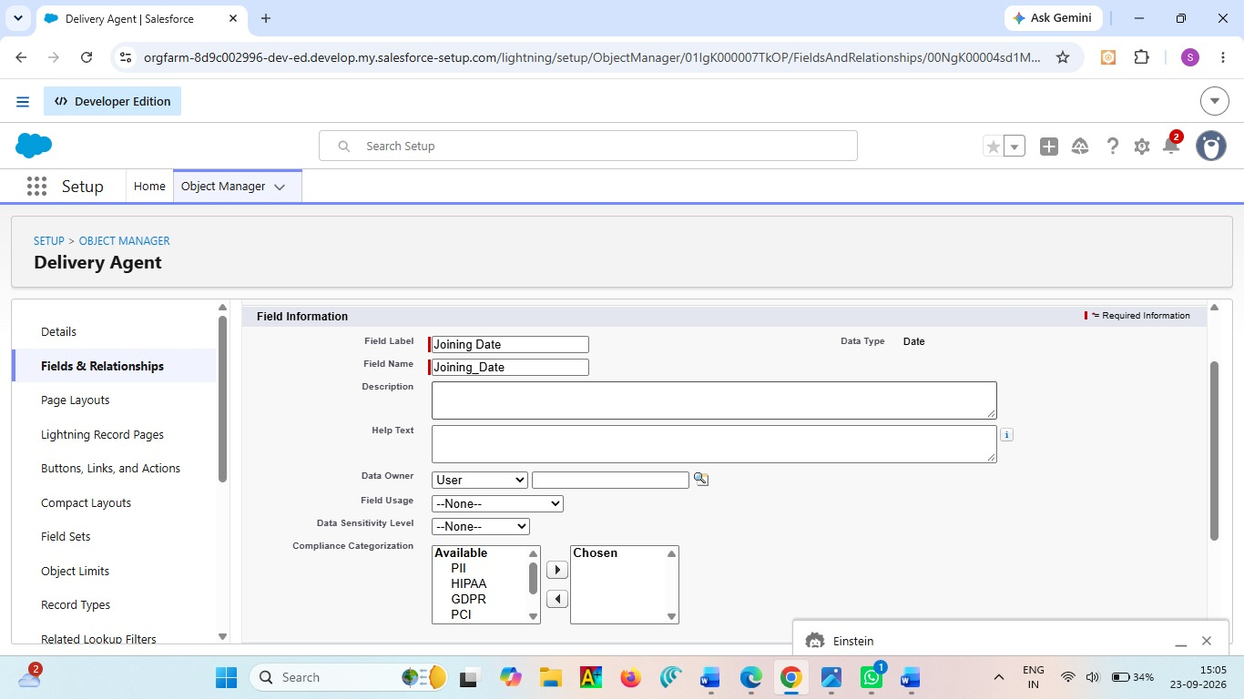

Activity 4: Creation of fields for Branch Object

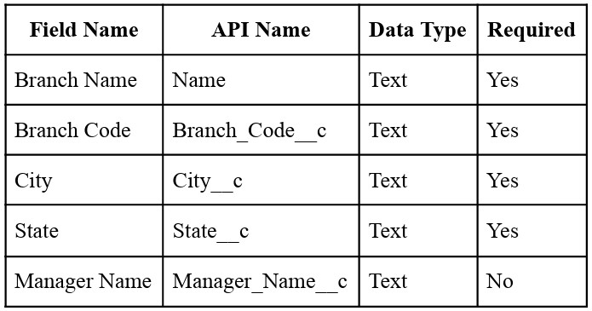

Create each field using:
- Setup → Branch__c → Fields → New
- Select respective Data Type
- Enter Field Label
- Save (Repeat for all fields)

Activity 5: Creation of fields for Delivery_Update Object

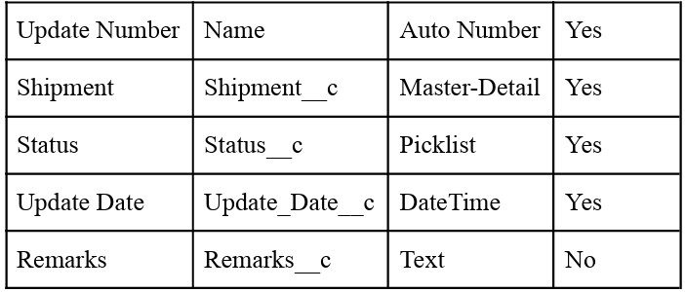

Status Picklist Values:
● In Transit
● Out for Delivery
● Delivered
● Delayed Required → Save

Activity 6: Creation of fields for Invoice Object
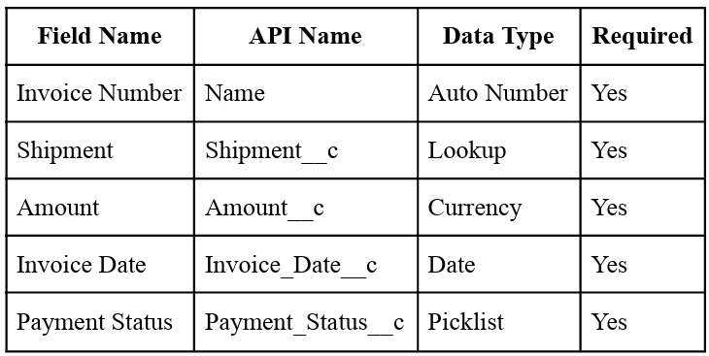

Payment Status Values
● Paid
● Unpaid
● Pending Required → Save

Relationships :

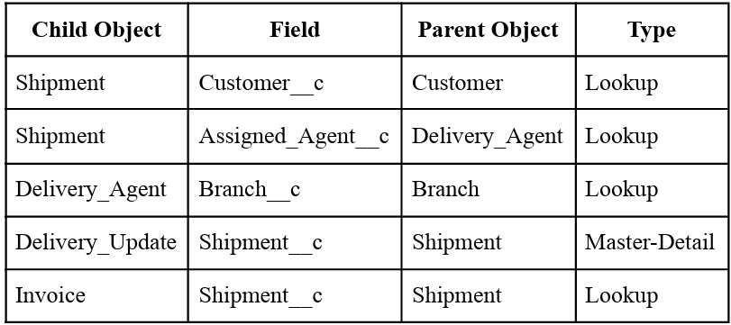

Relationship Creation Steps :
Activity 1 – Shipment → Customer
● Setup → Shipment__c → Fields → New
● Lookup Relationship
● Related Object: Customer__c
● Field Label: Customer
● Save

Activity 2 – Shipment → Delivery Agent
● Setup → Shipment__c
● New → Lookup
● Object: Delivery_Agent__c
● Label: Assigned Agent
● Save

Activity 3 – Delivery Agent → Branch
● Setup → Delivery_Agent__c
● New → Lookup
● Related Object: Branch__c
● Label: Branch
● Save
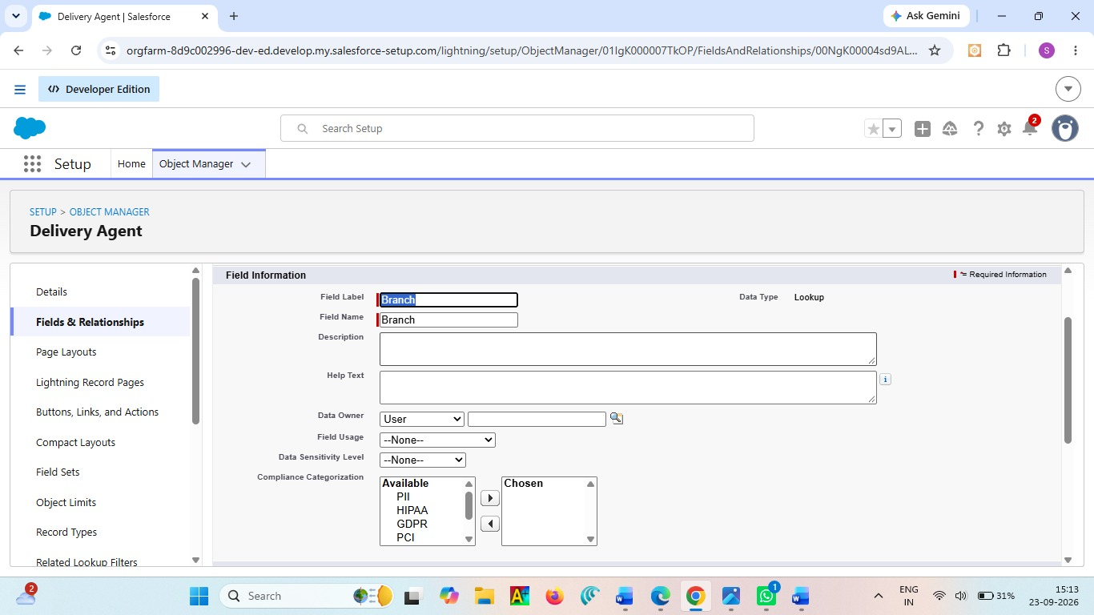

Activity 4 – Delivery Update → Shipment
● Setup → Delivery_Update__c
● New → Master-Detail
● Related Object: Shipment__c
● Save
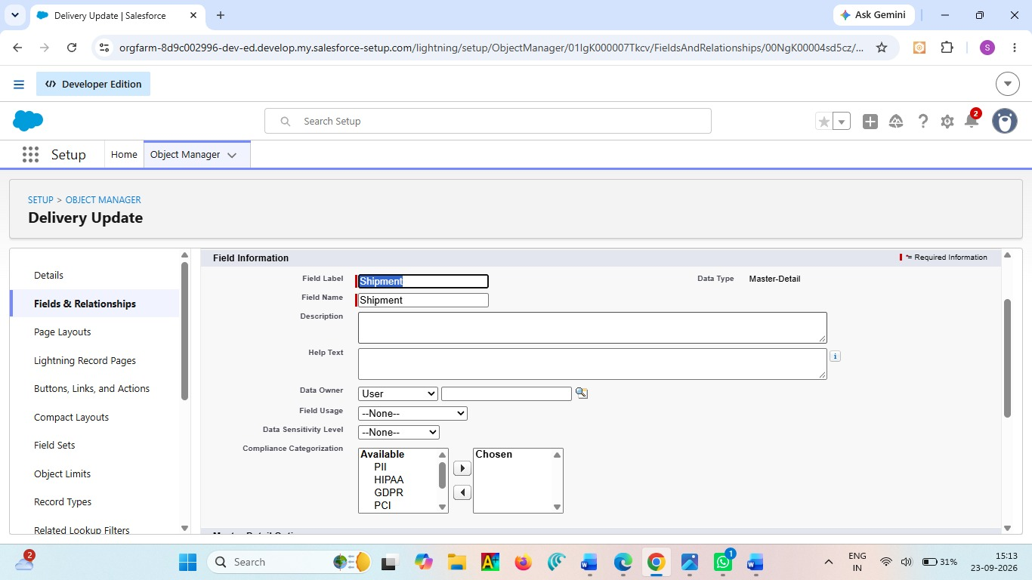

Activity 5 – Invoice → Shipment
● Setup → Invoice__c
● New → Lookup
● Object: Shipment__c
● Save
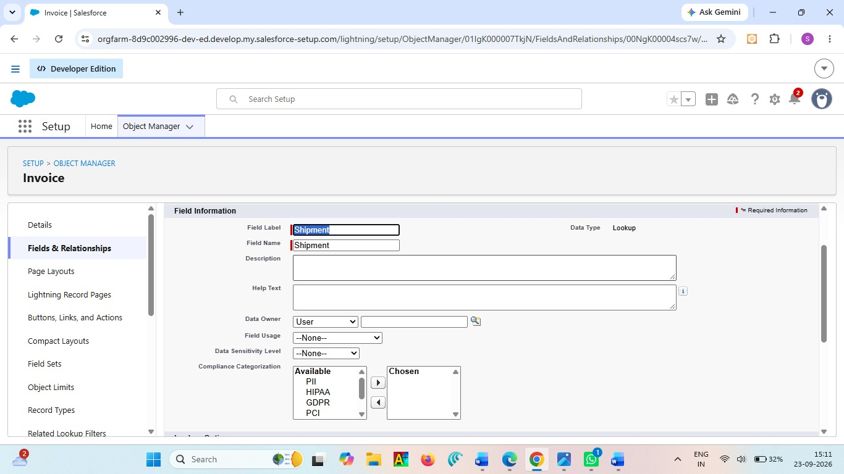

Milestone 5 - Validation Rules :
Validation Rules are used to check the data entered in the Courier Management System. They prevent incorrect or incomplete information from being saved in customer, shipment, and delivery records. This helps maintain accurate and reliable courier data
Activity 1: Create Validation Rules on Customer__c
1. Validation Rule: Email Must Not Be Blank Steps:
● Click the Gear icon → Setup
● Go to Object Manager
● Search and select Customer__c
● From the left menu, click Validation Rules
● Click New
● Rule Name: Email_Required
● Check Active
In Error Condition Formula, paste: ISBLANK(Email__c)
● Click Check Syntax
● Error Message: Email is required.
● Error Location: Field → Email
● Click Save.
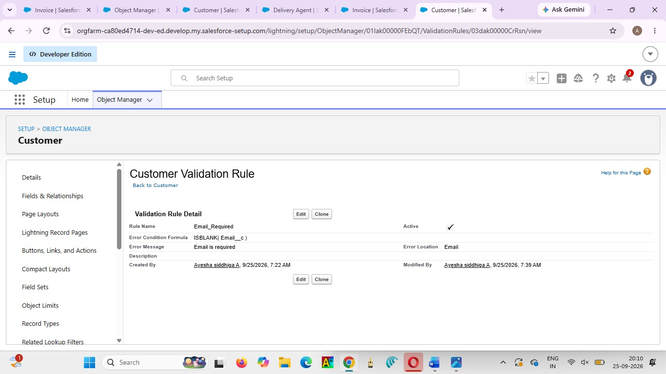

2. Validation Rule: Phone Must Be 10 Digits Steps:
● Setup → Object Manager → Customer__c
● Validation Rules → New
● Rule Name: Validate_Phone_Number
● Check Active Formula: LEN(Phone__c) <> 10
● Check Syntax
● Error Message: Phone number must be 10 digits.
● Error Location: Field → Phone
● Save
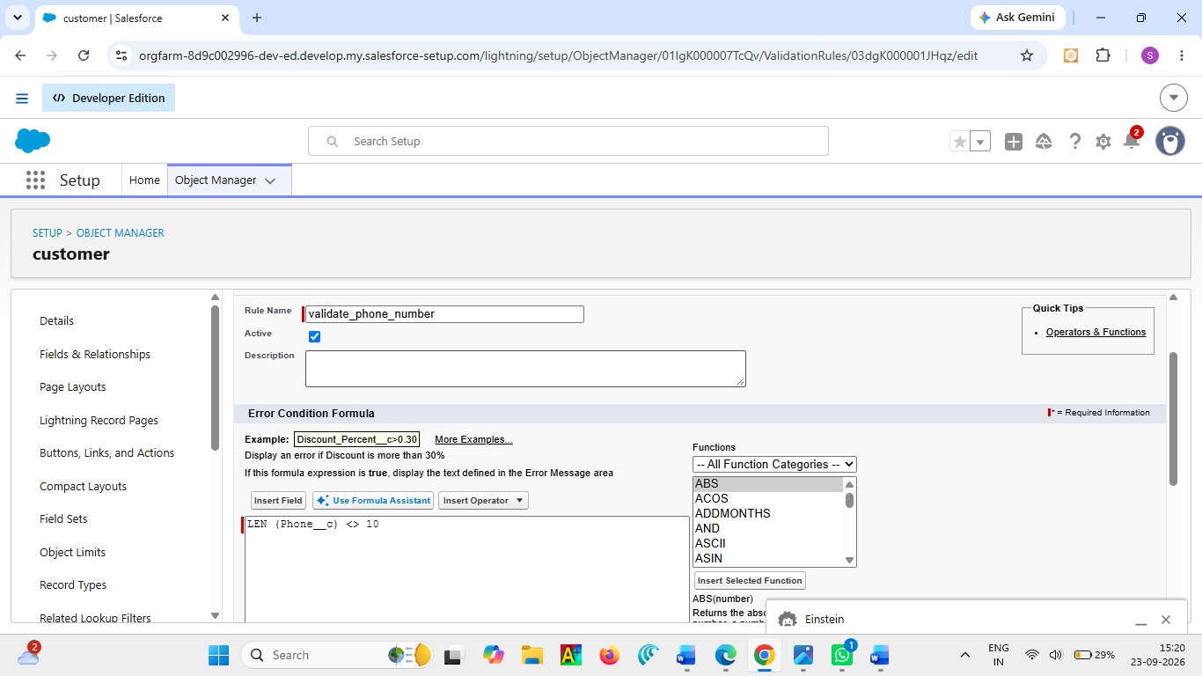

3. Validation Rule: Pincode Must Be 6 Digits Steps:
● Setup → Object Manager → Customer__c
● Validation Rules → New
● Rule Name: Validate_Pincode
● Active → Yes Formula: LEN(Pincode__c) <> 6
● Error Message: Pincode must be 6 digits.
● Location: Field → Pincode
● Save
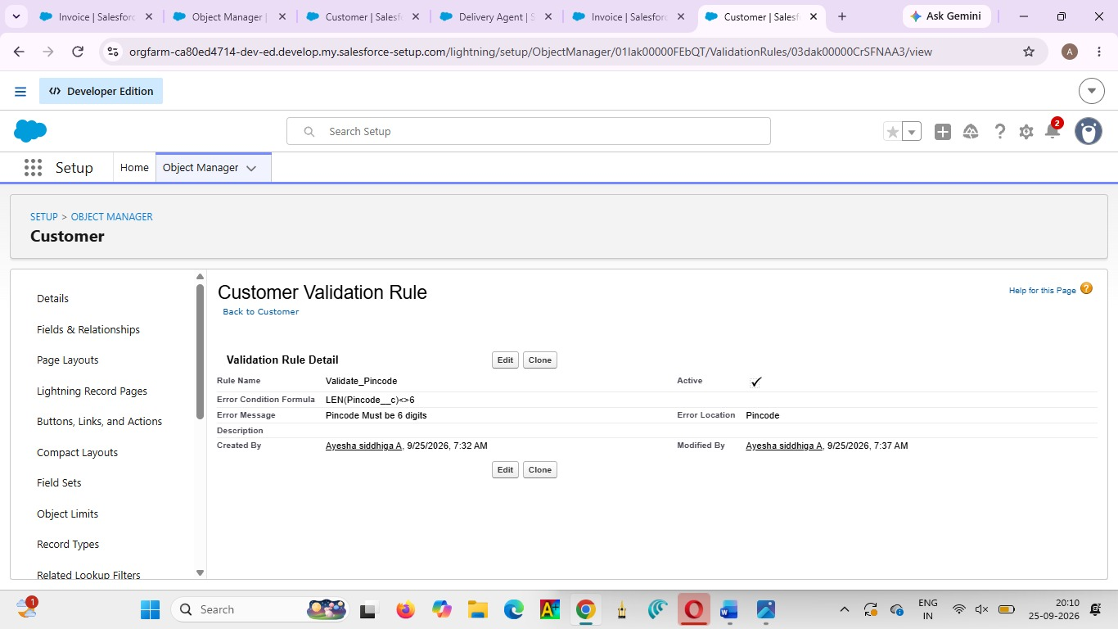

Activity 2: Create Validation Rules on Shipment__c
1. Validation Rule: Weight Must Be Greater Than Zero Steps:
● Setup → Object Manager → Shipment__c
● Click Validation Rules → New
● Rule Name: Validate_Weight
● Active → Checked Formula: Weight__c <= 0
● Check Syntax
● Error Message: Weight must be greater than zero.
● Location: Field → Weight
● Save
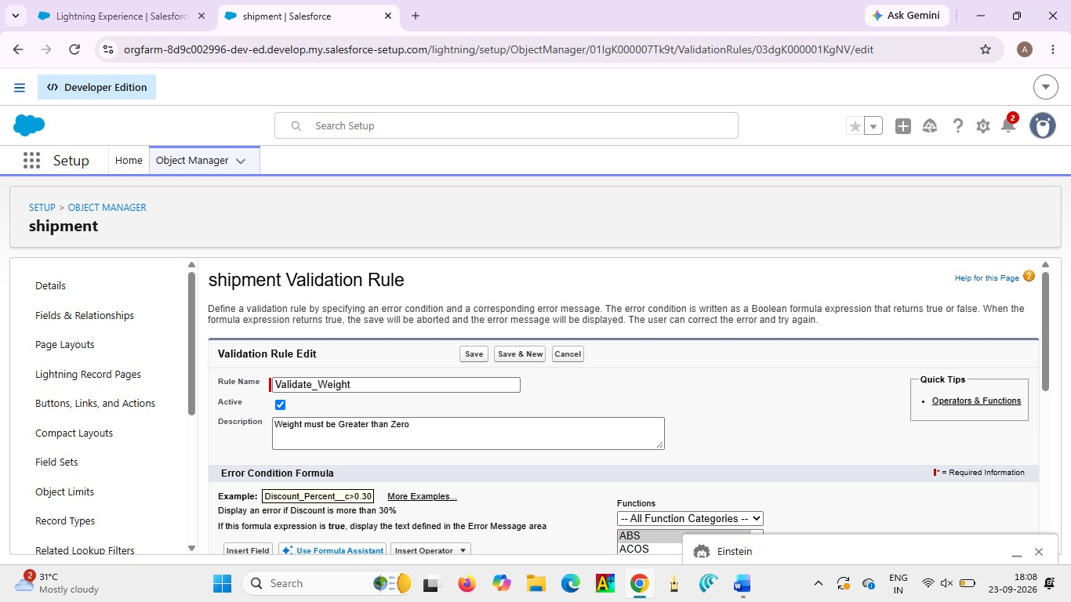

2. Validation Rule: Price Must Be Greater Than Zero Steps:
● Setup → Object Manager → Shipment__c
● Validation Rules → New
● Rule Name: Validate_Price
● Active → Yes Formula: Price__c <= 0
● Error Message: Price must be greater than zero.
● Location: Field → Price
● Save
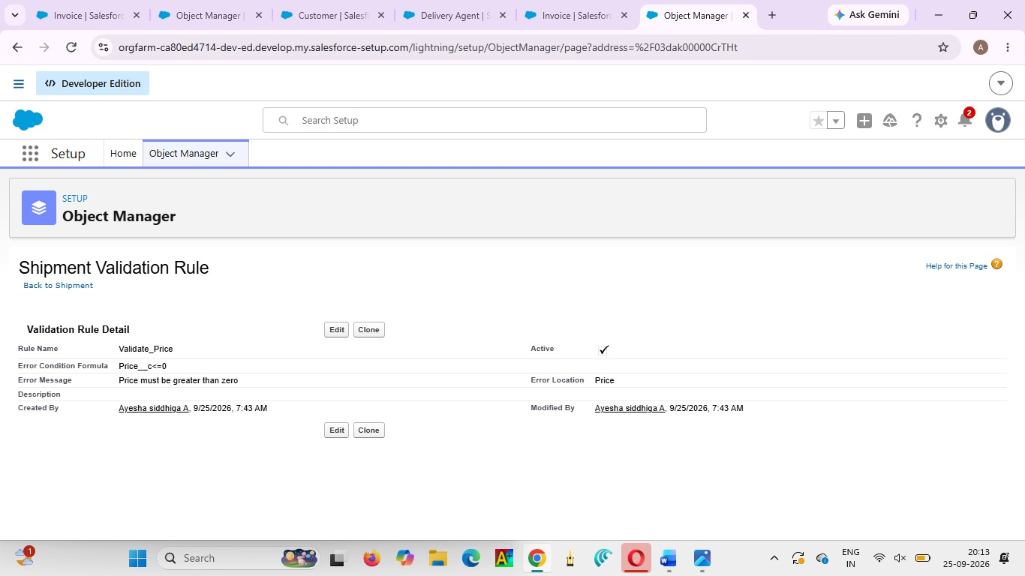

3. Validation Rule: Expected Date Cannot Be in the Past Steps:
● Setup → Object Manager → Shipment__c
● Validation Rules → New
● Rule Name: Validate_Expected_Date Formula: Expected_Date__c < TODAY()
● Check Syntax
● Error: Expected delivery date cannot be in the past.
● Location: Field → Expected Date
● Save
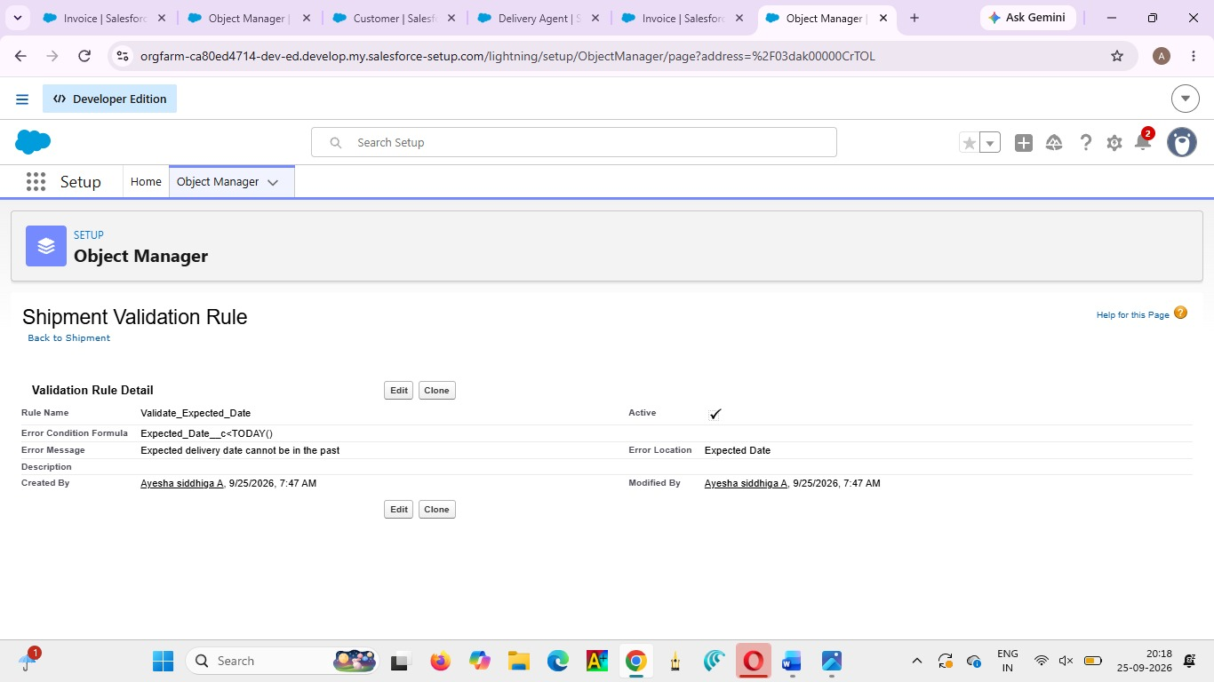

Activity 3: Create Validation Rules on Delivery_Agent__c
1. Validation Rule: Email Must Be Valid Steps:
● Setup → Object Manager → Delivery_Agent__c
● Validation Rules → New
● Rule Name: Validate_Agent_Email
● Active → Yes Formula: NOT(CONTAINS(Email__c, "@"))
● Error Message: Enter a valid email address.
● Location: Field → Email
● Save
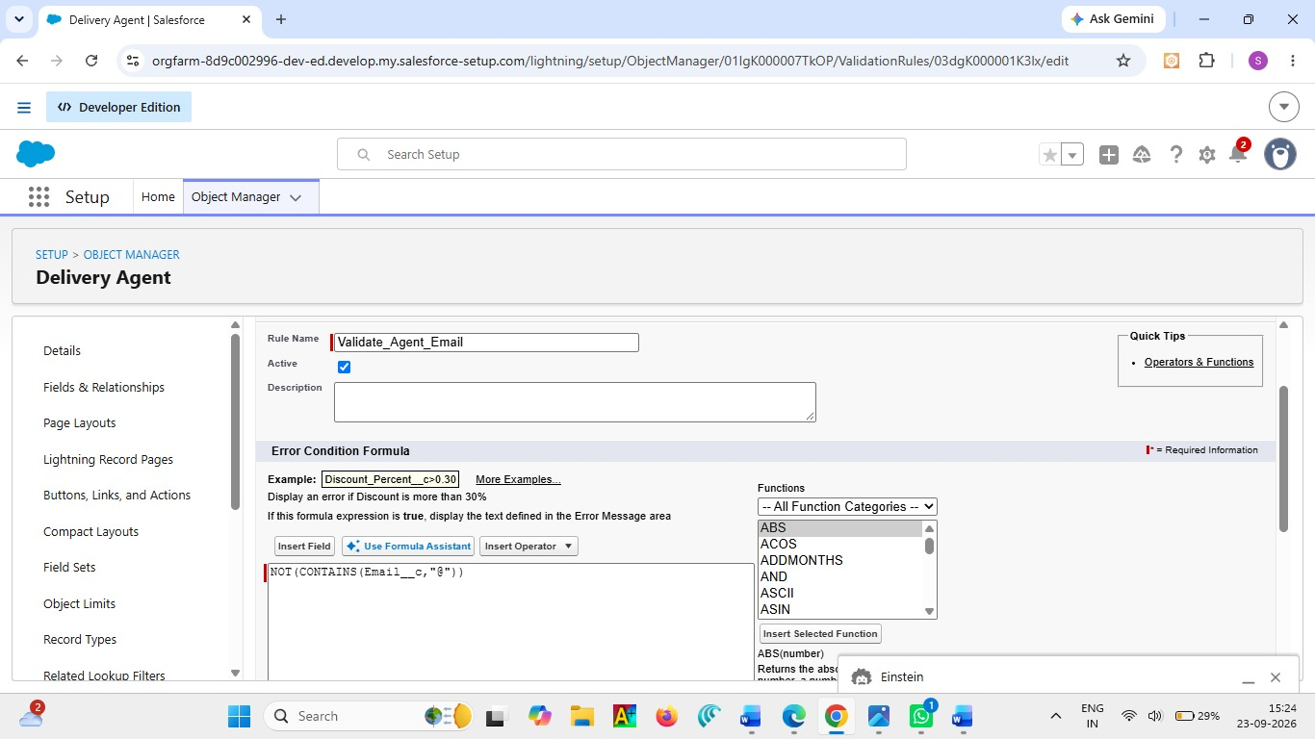

Activity 4: Create Validation Rules on Branch__c
- Validation Rule: Branch Code Must Not Be Blank Steps:
● Setup → Object Manager → Branch__c
● Validation Rules → New
● Rule Name: Branch_Code_Required Formula: ISBLANK(Branch_Code__c)
● Error Message: Branch Code is mandatory.
● Location: Field → Branch Code
● Save
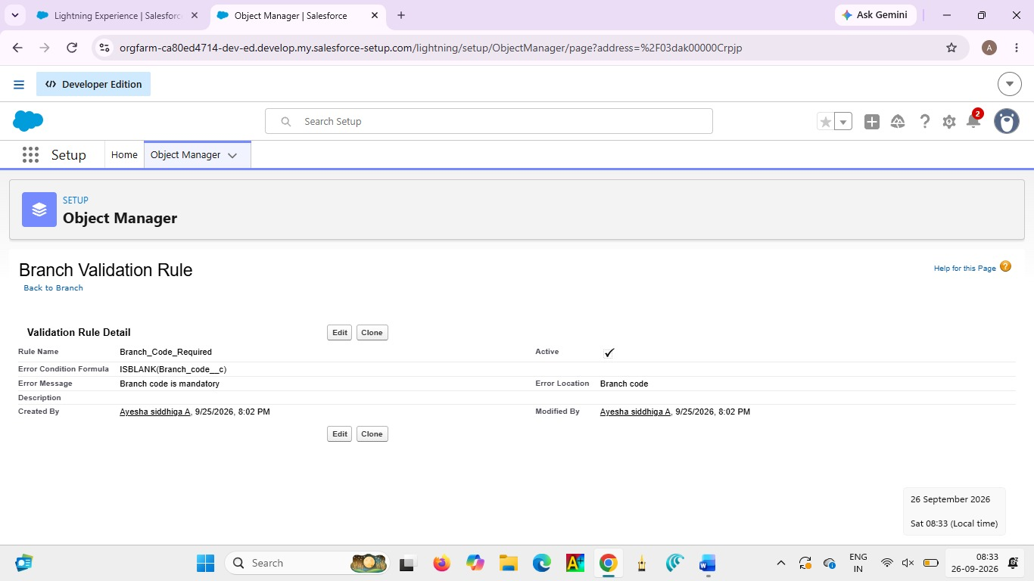

Activity 5: Create Validation Rules on Delivery_Update__c
- Validation Rule: Remarks Required If Status is Delayed
Steps:
● Setup → Object Manager → Delivery_Update__c
● Validation Rules → New
● Rule Name: Remarks_Required_For_Delay
Formula: AND( ISPICKVAL(Status__c, "Delayed"), ISBLANK(Remarks__c) )
● Error Message: Remarks are required when status is Delayed.
● Location: Field → Remarks
● Save
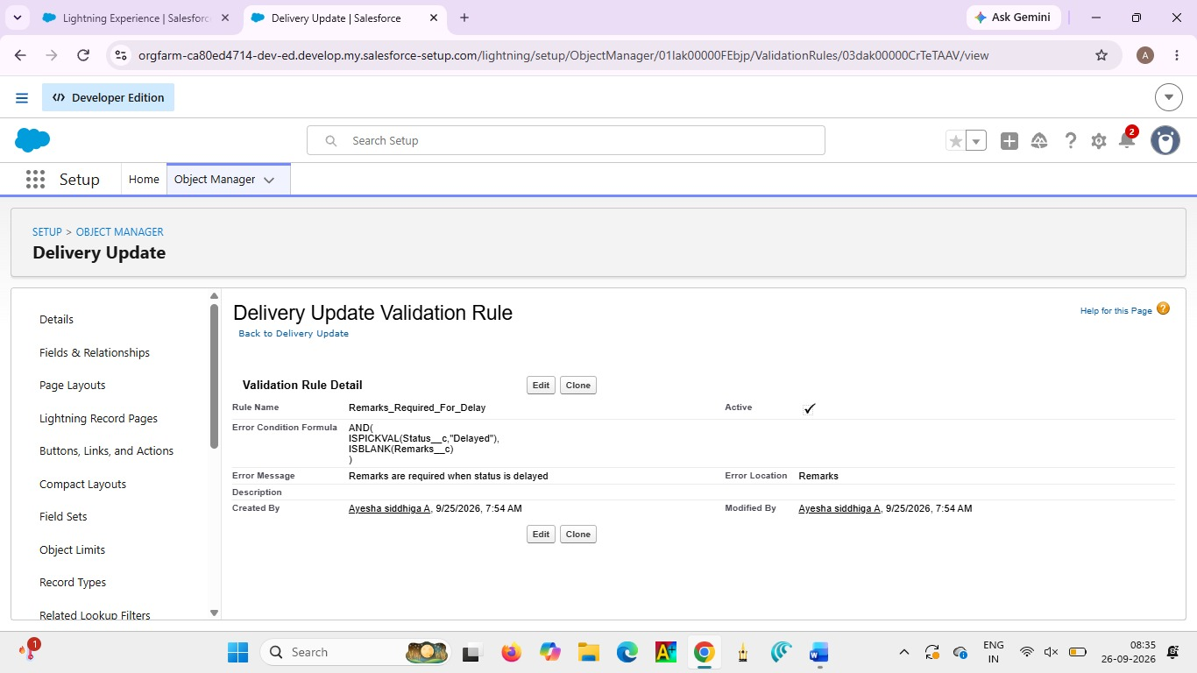

Milestone 6 - Page Layouts :
Page Layouts are used to organize the fields and sections displayed for each Salesforce record. They help users view and enter courier information clearly, such as customer, shipment, delivery agent, and invoice details.

Activity 1: Edit Page Layout for Customer__c Steps:
● Setup → Object Manager → Customer__c
● Click Page Layouts
● Click the default layout (usually Customer Layout)
Sections to Add & Arrange:
● Open the default layout
● In the top palette, click “Section”
● Drag the Section and drop it anywhere on the layout
A pop-up appears → Fill details:
● Section Name: “Customer Information”
● Layout:
○ 1-Column or
○ 2-Column (recommended)
● Tab-Key Order: Top-Down
● Click OK The new section will appear on the layout.
● Drop fields inside the section (it will highlight).
● Repeat the same for each field.

Section 1: Customer Information
● Customer Name
● Customer Type
● Email
● Phone
● Is Active Section

2: Address Details
● Address
● City
● State
● Pincode
9. Edit the layout as needed
10. Click Save.

Activity 2: Edit Page Layout for Shipment__c Steps:
● Setup → Object Manager → Shipment__c
● Click Page Layouts
● Open the default Shipment Layout
Sections to Add: Section 1: Shipment Details
● Tracking Number
● Customer
● Shipment Type
● Weight
● Price
● Status
Section 2: Address Information
● Source Address
● Destination Address

Section 3: Delivery Information
● Expected Date
● Assigned Agent
● Arrange fields properly
● Click Save
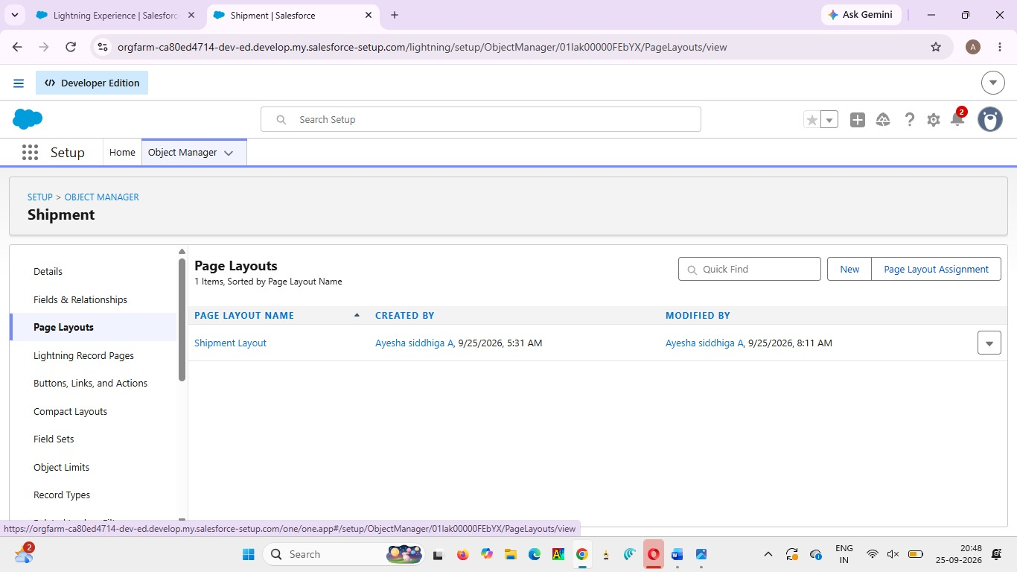

Activity 3: Edit Page Layout for Delivery_Agent__c
Steps:
● Setup → Object Manager → Delivery_Agent__c
● Page Layouts
● Open default Delivery Agent Layout
Arrange Fields:
Agent Details
● Agent Name
● Email
● Phone
● Branch
● Status
● Joining Date
Additional Information
● Related Shipments
● Related Delivery Updates
● Edit → Save

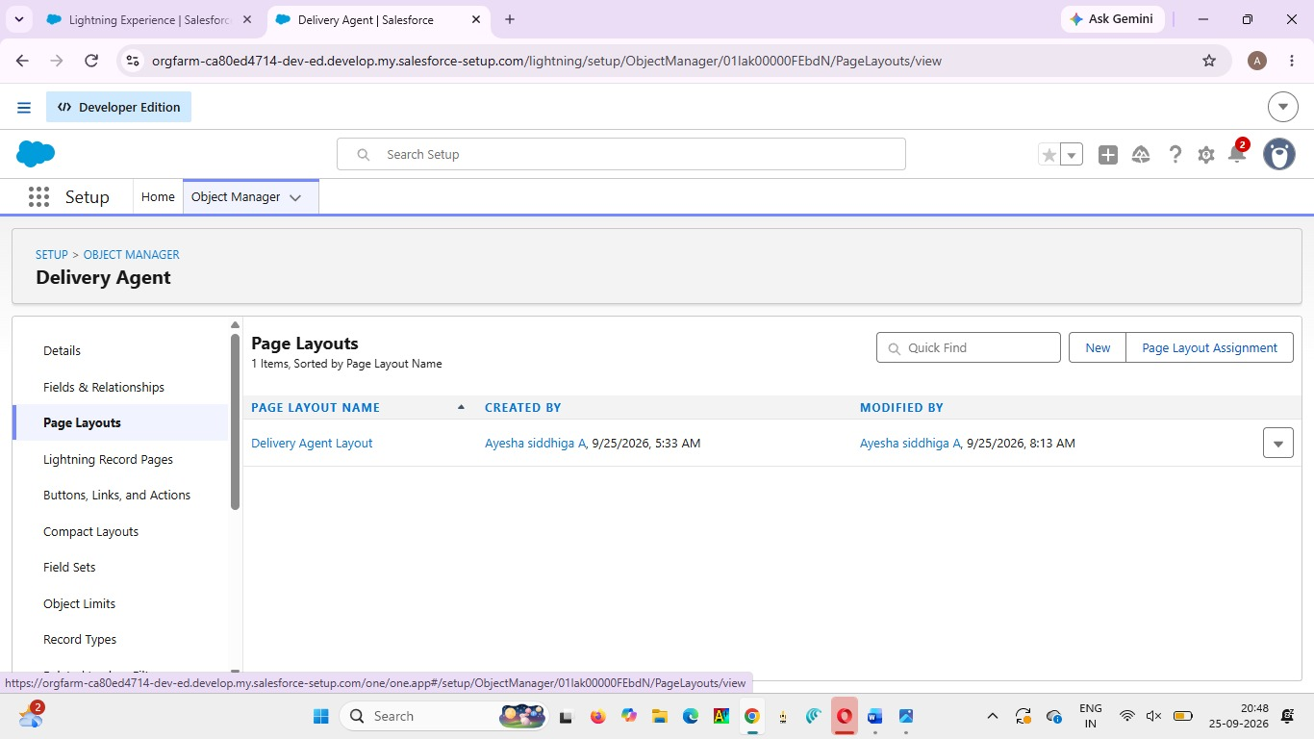

Activity 4: Edit Page Layout for Branch__c Steps:
● Setup → Object Manager → Branch__c
● Page Layouts
● Open default
Branch Layout Sections: Branch Information
● Branch Name
● Branch Code
● City
● State
● Manager Name
● Arrange fields
● Click Save
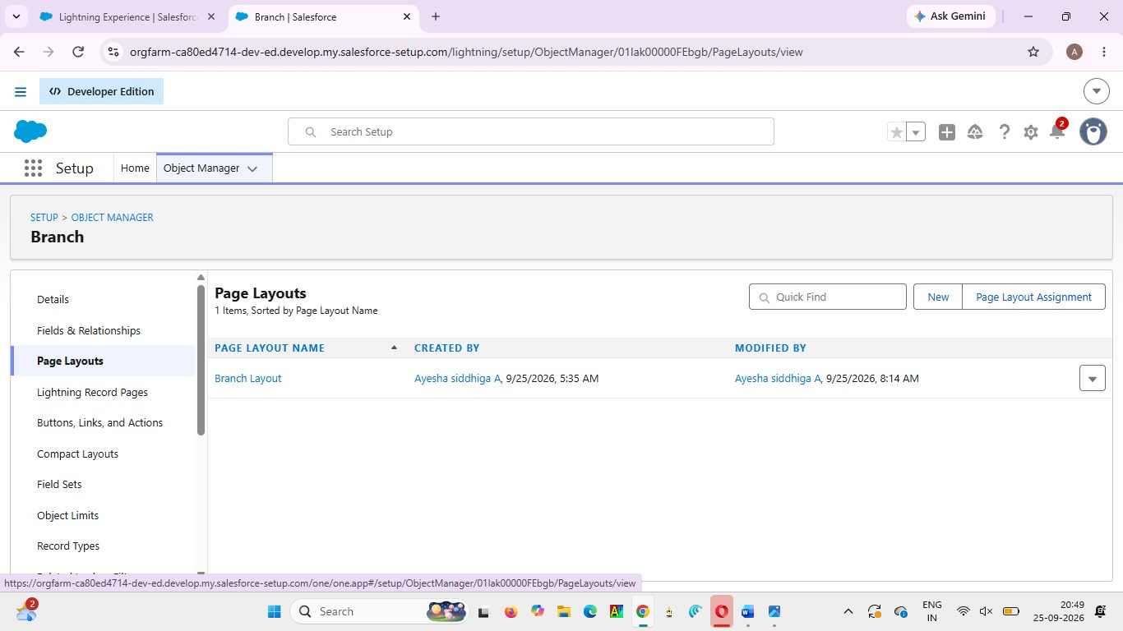

Activity 5: Edit Page Layout for Delivery_Update__c Steps:
● Setup → Object Manager → Delivery_Update__c
● Page Layouts
● Open default
Delivery Update Layout Sections: Update Information
● Update Number
● Shipment
● Status
● Update Date
● Remarks
● Arrange properly
● Click Save
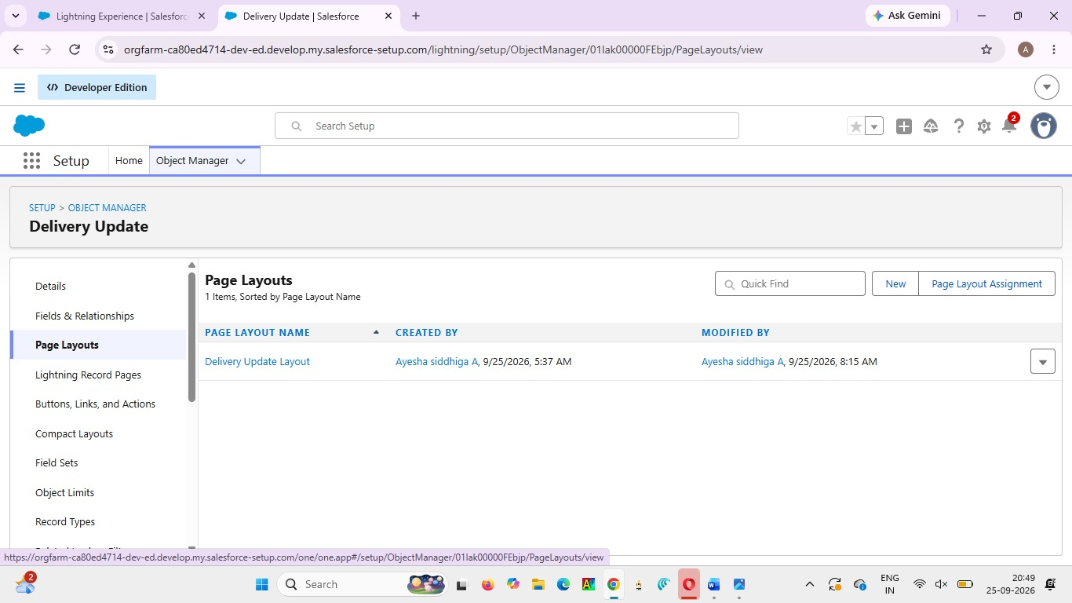

Activity 6: Edit Page Layout for Invoice__c Steps:
● Setup → Object Manager → Invoice__c
● Page Layouts
● Open default Invoice Layout
Sections: Invoice Details
● Invoice Number
● Shipment
● Amount
● Invoice Date
● Payment Status
● Arrange fields as needed
● Click Save
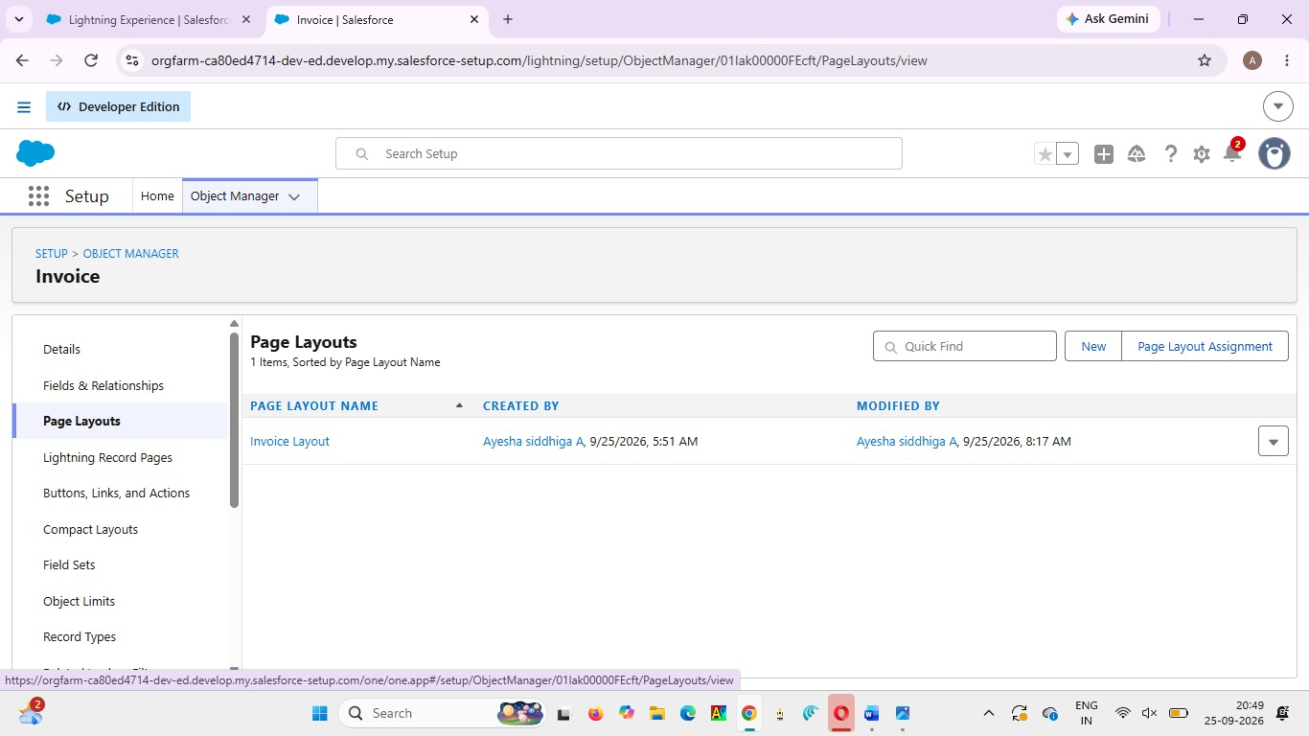

Milestone 7 - Flows
In Salesforce, a flow is a powerful tool that allows you to automate business processes, collect and update data, and guide users through a series of screens or steps. Flows are built using a visual interface and can be created without any coding knowledge.
Activity 1: Auto-Update Shipment Status When Delivery Update is Created Scenario:
Whenever a Delivery_Update__c record is created, automatically update the related Shipment__c Status with the latest status from Delivery Update.

Part 1: Create the Record-Triggered Flow
Step 1: Open Flow Builder
● Click the Gear Icon → Click Setup
● In the Quick Find box (left side), type Flows
● Click Flows
● Click the New Flow button
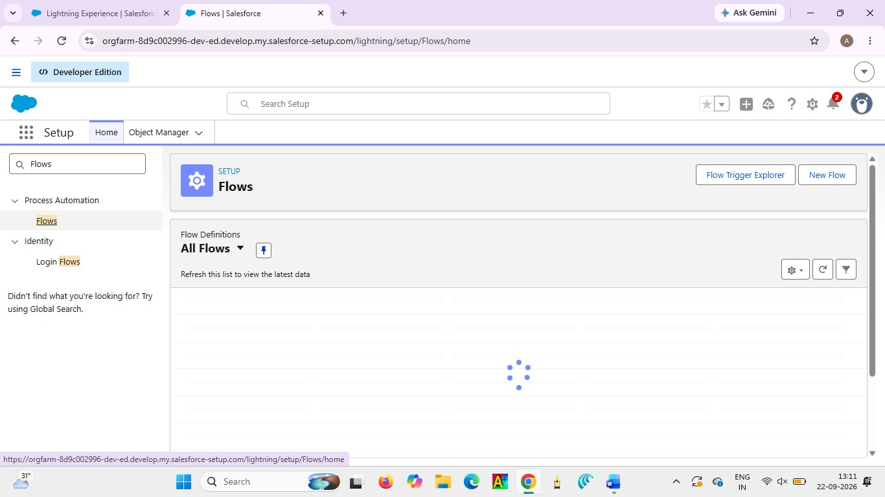

● Select Record-Triggered Flow
● Click Create
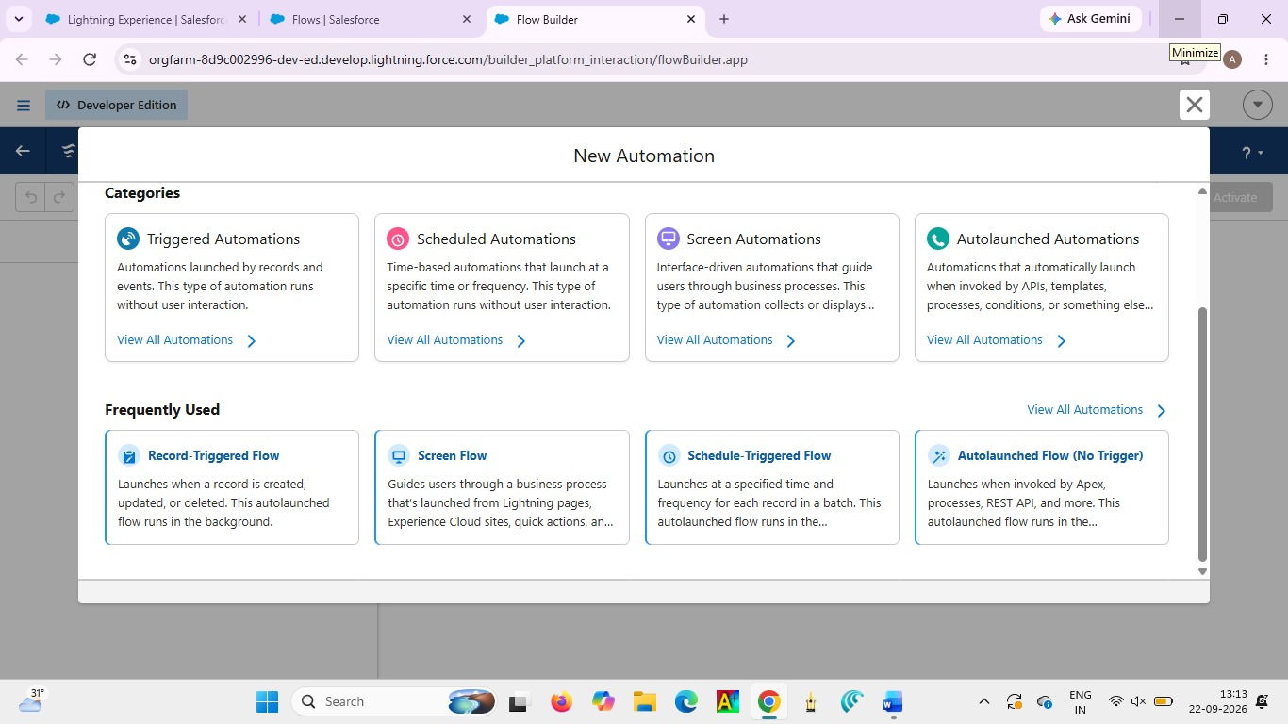
Step 2: Configure the Start (Trigger)
On the Start panel on the right:
● Object: select Delivery_Update__c
● Trigger the Flow When:
○ Select A record is created
● Condition Requirements:
○ Choose: None (Always Run the Flow)
● Optimize the Flow For:
○ Select Actions and Related Records
● Click Done
Part 2: Update Related Shipment Record
Step 3: Add “Update Records” Element
● Click the + icon under the Start element
● Select Update Records Configure the Update Records Element:
● Label: Update_Shipment_Status
● How to Find Records to Update:
○ Select Specify conditions to identify records Set Filter Conditions:
● Object: Shipment__c
● Field: Id
● Operator: Equals
● Value: {!$Record.Shipment__c}
(This means update the Shipment linked to the Delivery Update)
Set Field Values to Update
Add field mapping:
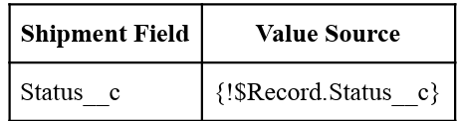
(This copies status from Delivery Update to Shipment)
● Click Done
Part 3: Save and Activate
Step 4: Save Flow
● Click Save (top-right)
● Flow Label: Auto_Update_Shipment_Status
● API Name will auto-fill
● Click Save
Step 5: Activate Flow
● Click Activate
● Flow status should show Active
Final Flow Layout:
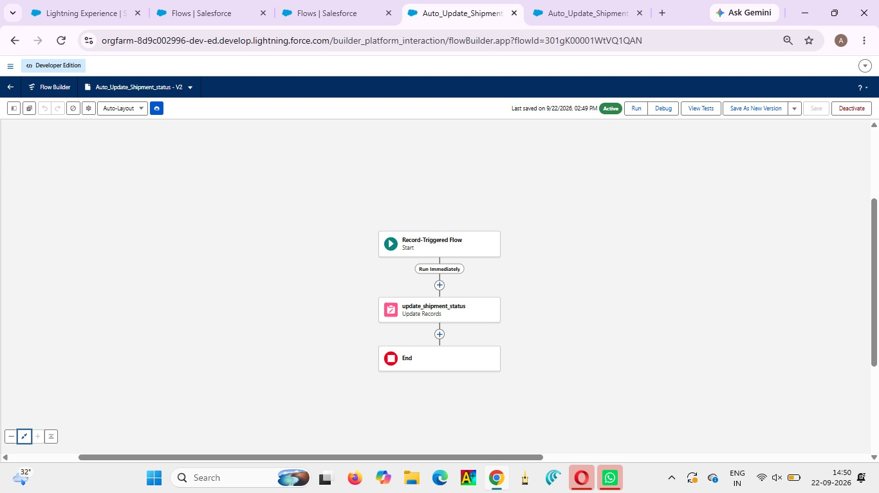
Milestone 8 - The Lightning App :
What is an App ?
A Salesforce App is a collection of tabs and features used to access related records in one place.It provides an organized interface for managing the Courier Management System.

Activity 1: Create a Lightning App
Create the Courier Management System App
- From Setup, enter App Manager in the Quick Find and select App Manager.
2. Click New Lightning App.
○ Enter the Courier Management System as the App Name.
3. Upload an image or icon for the app, then click Next.
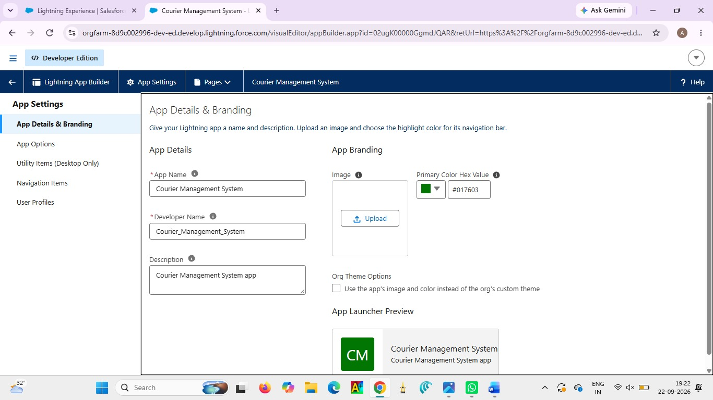

4. Under App Options, leave the default selections and click Next.
5. Under Utility Items, leave as it is and click Next.
6. From Available Items, select the following and move them to Selected Items:
○ Customer
○ Shipment
○ Delivery Agent
○ Branch
○ Delivery Update
○ Invoice
○ Reports
○ Dashboards
7. Click Next.
8. From Available Profiles, select System Administrator and move it to Selected Profiles.
9. Click Save & Finish.
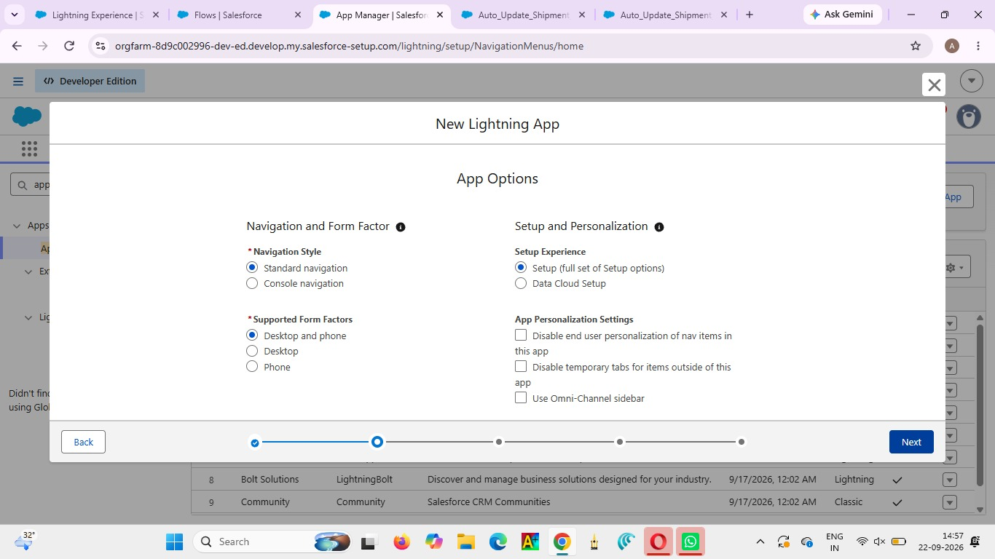
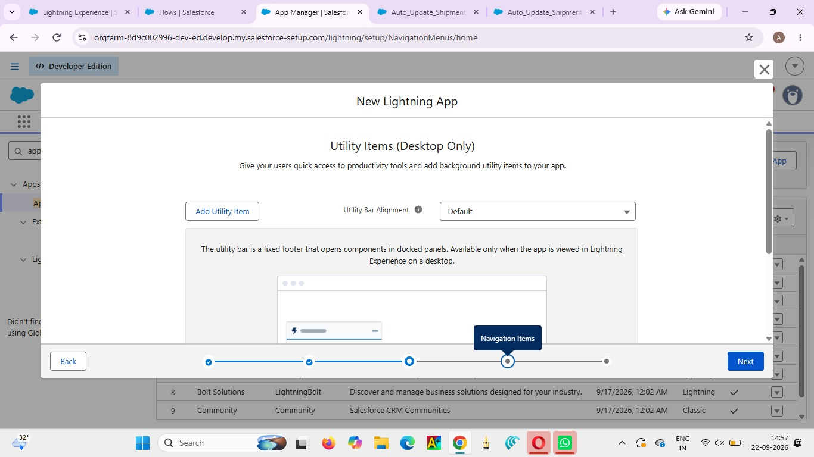
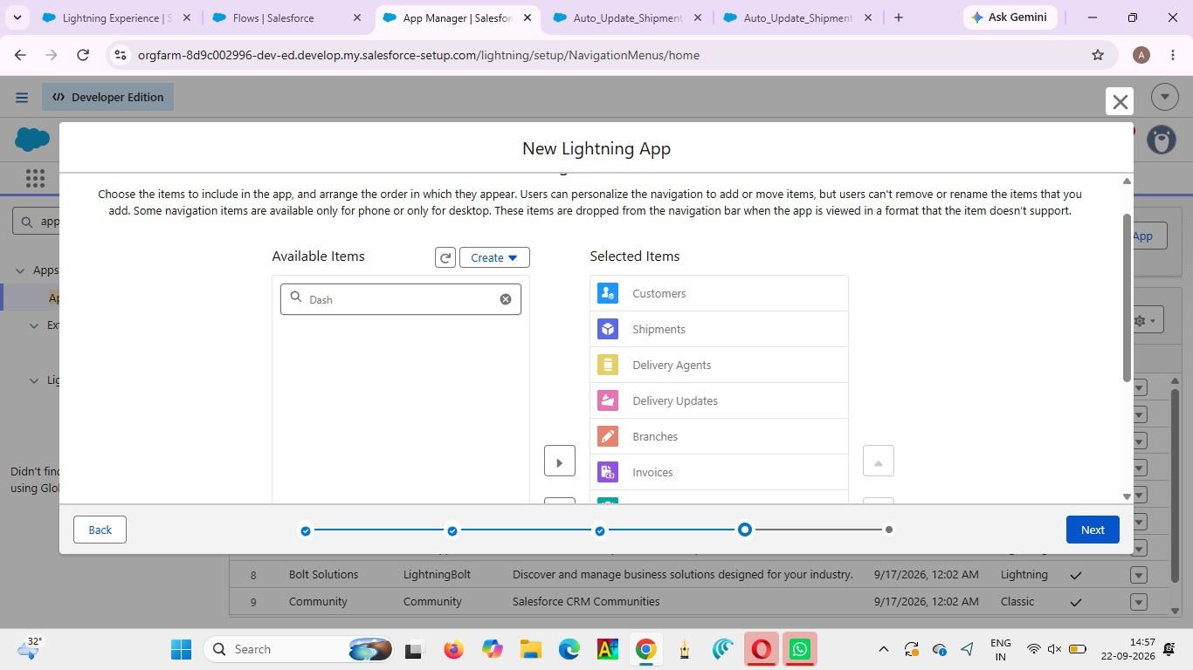

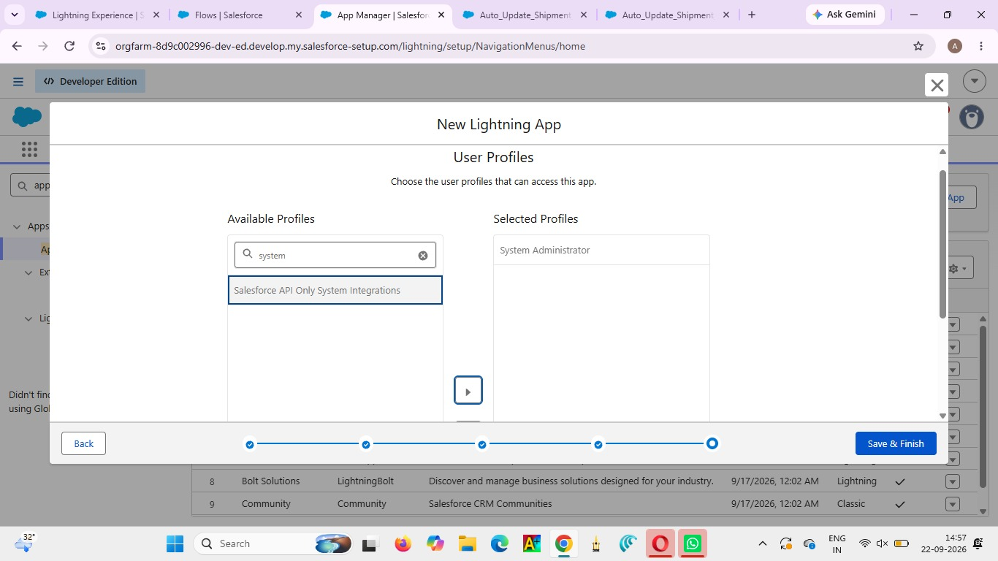

Milestone 9- Profile:
What is a profile?
A Profile in Salesforce defines the permissions and access given to a user.
It controls what users can view, create, edit, and manage in the Courier Management System.

Activity 1: Create a Custom Profile – Courier Admin Create a Custom Profile:
1. From Setup, enter Profiles in the Quick Find box.
2. Click Profiles.
3. Click New Profile.
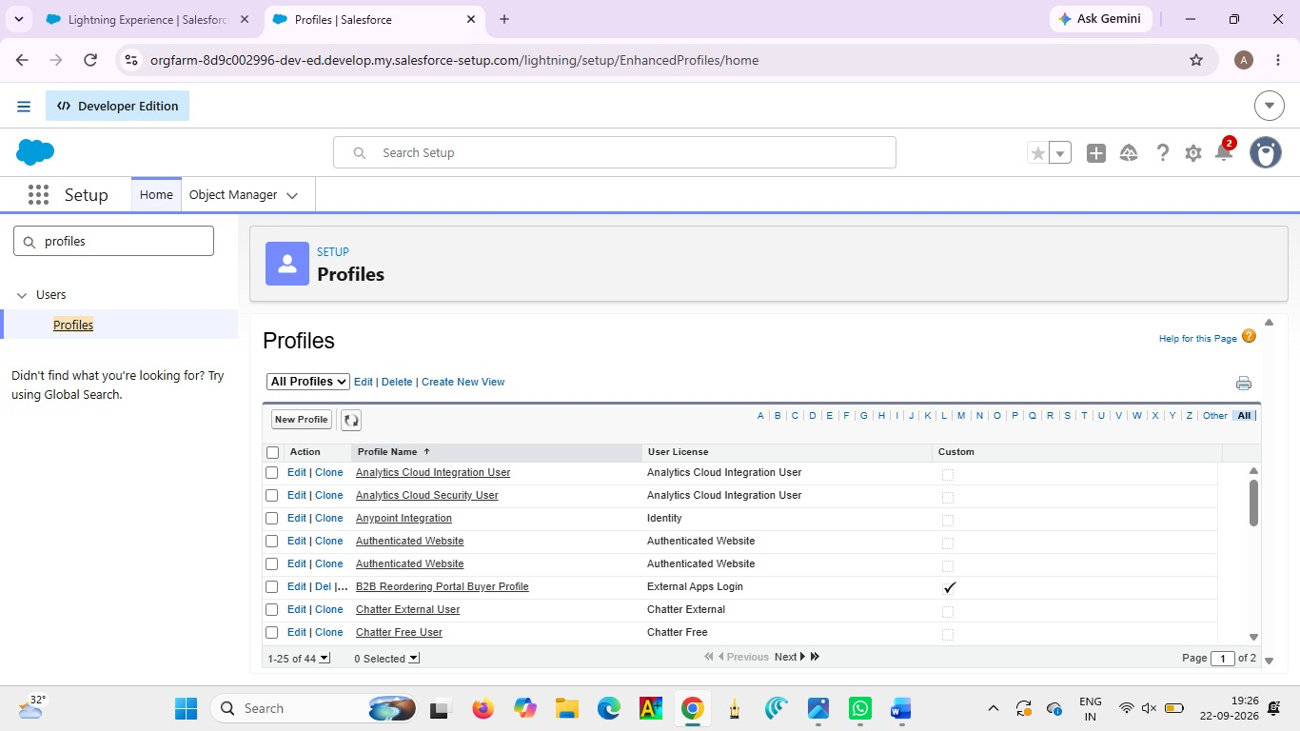

4. Select Existing Profile as: System Administrator.
5. Enter Profile Name: Courier Admin.
6. Click Save.
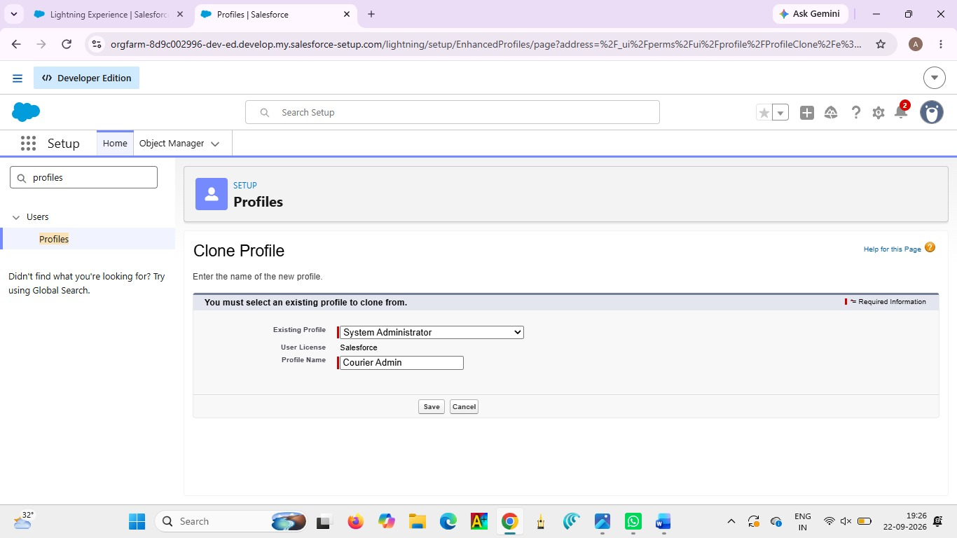

Why use System Administrator as Base?
It already has:
● Modify All Data
● Customize Application
● Full CRUD access on all objects
By cloning it, the Courier Admin profile automatically inherits full access. You can later restrict permissions if required.

Activity 2: Create a Custom Profile – Branch Manager
Steps:
1. From Setup, enter Profiles in the Quick Find box.
2. Click Profiles.
3. Click New Profile.
4. Select Existing Profile as: Standard Platform User.
5. Enter Profile Name: Branch Manager.
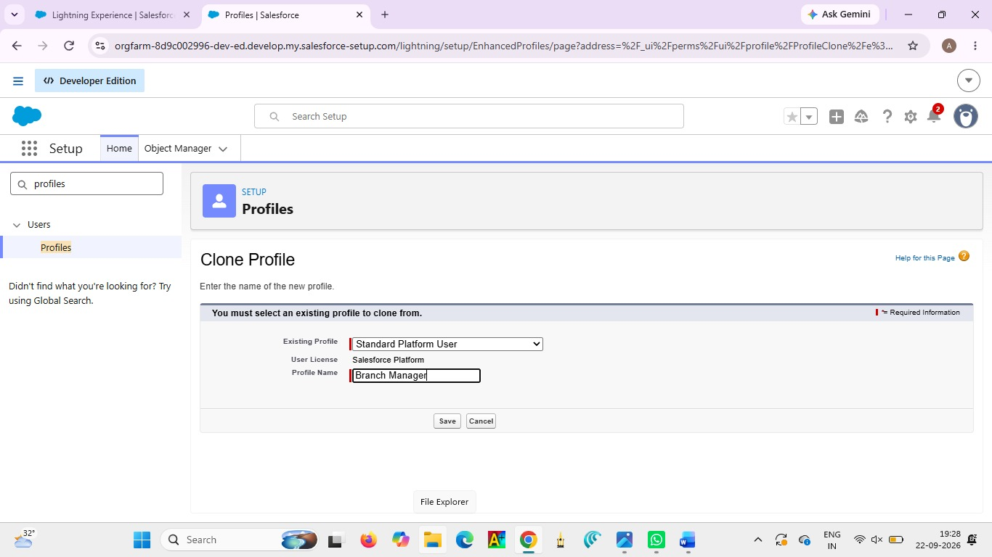

6. Click Save.
7. Click Edit on the Branch Manager profile.
Set App & Tab Settings
Under Assigned Apps / Custom App Settings, set the default app to:
Courier Management System App

Ensure Visible Tabs Include:
Set these tabs as Default On or Visible:
● Customers
● Shipments
● Delivery Agents
● Branches
● Delivery Updates
● Invoices
● Reports
● Dashboards

Custom Object Permissions
Scroll to Custom Object Permissions and set access as follows:
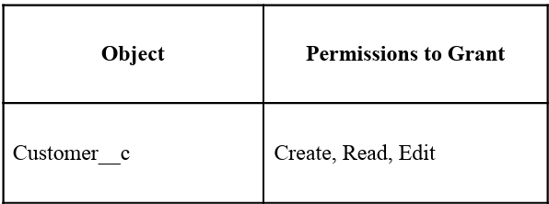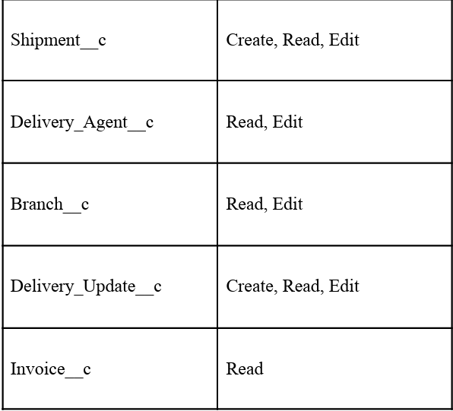
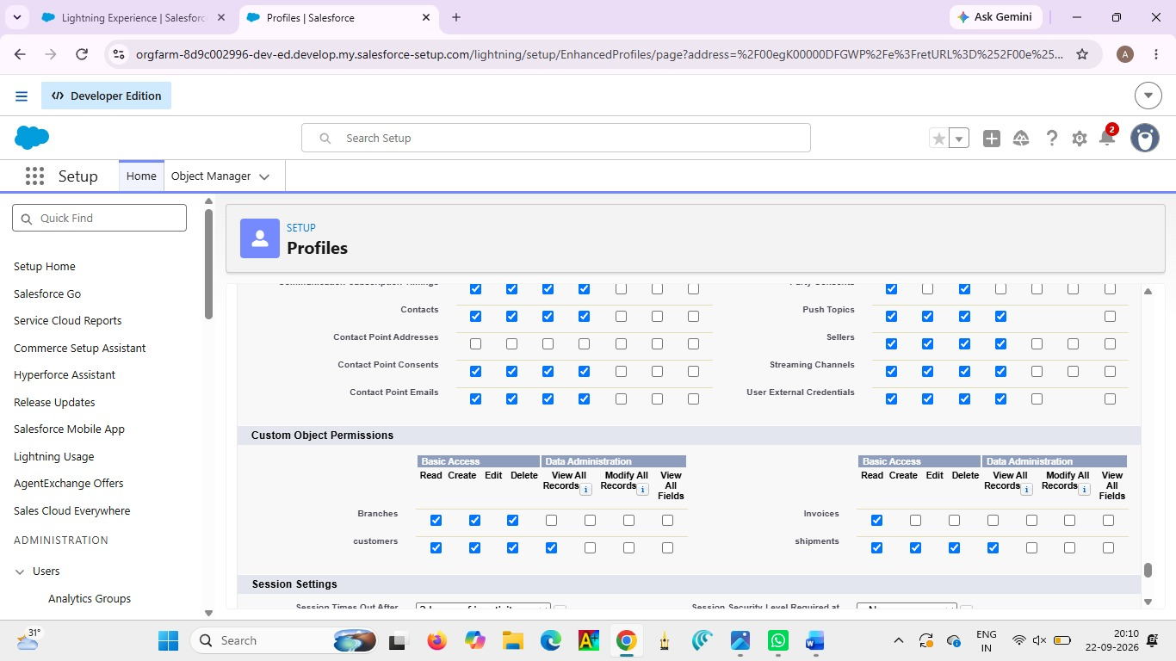

Session & Password Settings
Under Session Settings:
● Session Timeout: 2 Hours of Inactivity
Under Password Policies:
● User passwords expire in: Never Expires
● Minimum Password Length:
8 Click Save.

Activity 3: Create a Custom Profile – Delivery Agent Steps:
1. Setup → Quick Find → Profiles
2. Click New Profile
3. Existing Profile: Standard Platform User
4. Profile Name: Delivery Agent
5. Click Save
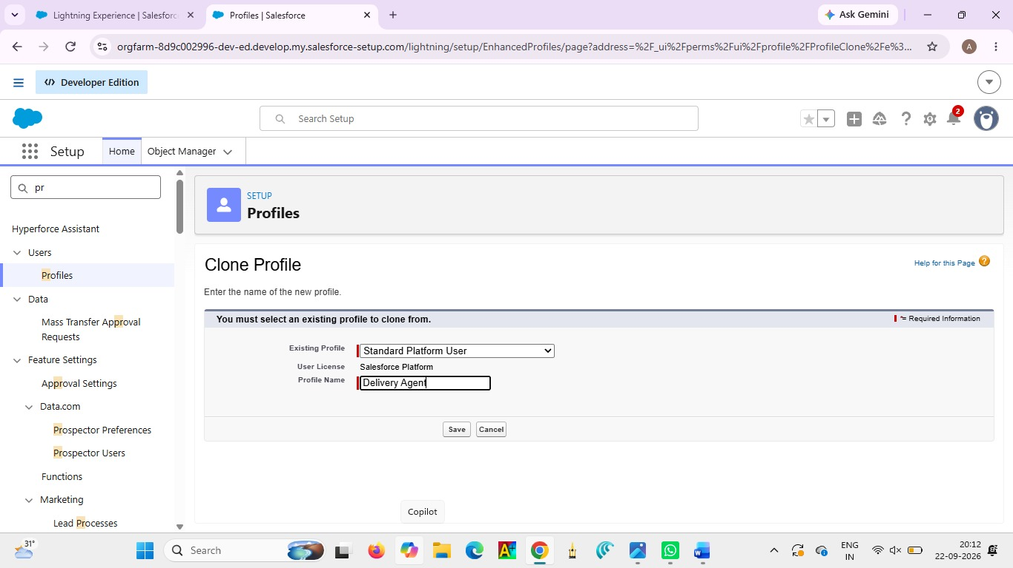

App & Tab Access
Default App: Courier Management System
Visible Tabs:
● Shipments
● Delivery Updates

Object Permissions :

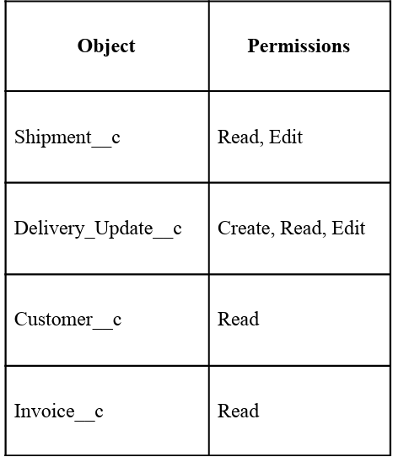
Restrictions
Permissions Read, Edit Create, Read, Edit Read Read
● No access to Branch editing
● No delete permissions
● Limited reporting access Click Save.

Activity 4: Create a Custom Profile – Customer Support Steps:
● Setup → Profiles → New Profile
● Base Profile: Standard User
● Profile Name: Customer Support
Access Configuration
Tabs Visible:
● Customers
● Shipments
● Delivery Updates

Object Permissions :
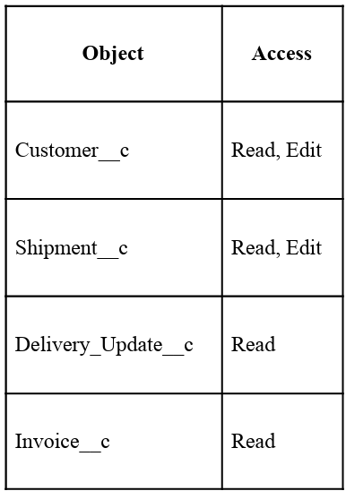

Session Settings
Read, Edit Read Read
● Session Timeout: 2 Hours
● Password Length:
8 Click Save

Final Profiles Created in Project :
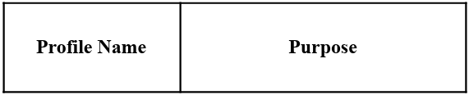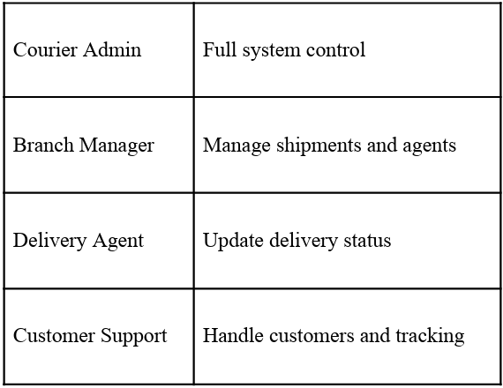

Milestone 10- Role:
In Salesforce, roles are used to determine which users have access to certain data and functions within the system. They are also used to define the reporting hierarchy within an organization. Users with higher roles have greater access to data and more control over the system.

Activity 1: Creation of Courier Admin Role Creation of Role:
1. From the Quick Find box, search for Roles and click on the Roles option.
2. Select Set Up Roles.
3. Click on Expand All and click Add Role under CEO.
4. Give Label as “Courier Admin”.
○ The Role Name will auto-populate.
5. Click Save.
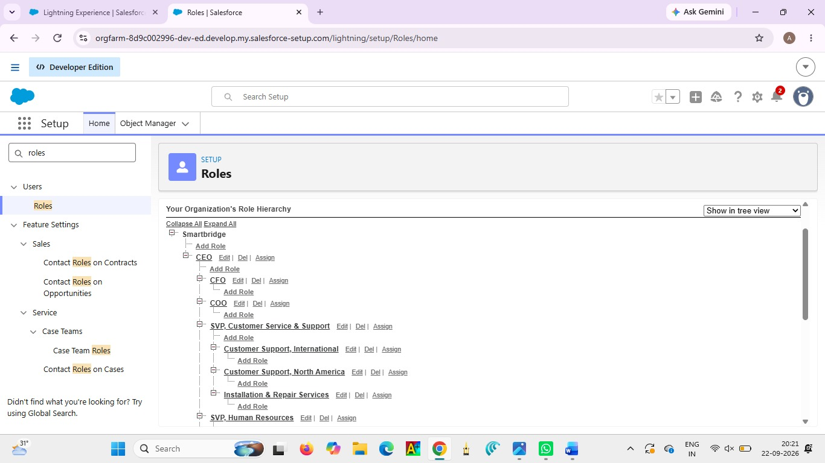

Activity 2: Creating Branch Manager Role Under Courier Admin Role
Create another role:
1. Create a role with the name “Branch Manager”.
2. Below the Courier Admin, click on Add Role.
3. Enter the label name as “Branch Manager” and the Role Name will automatically populate.
4. Click Save
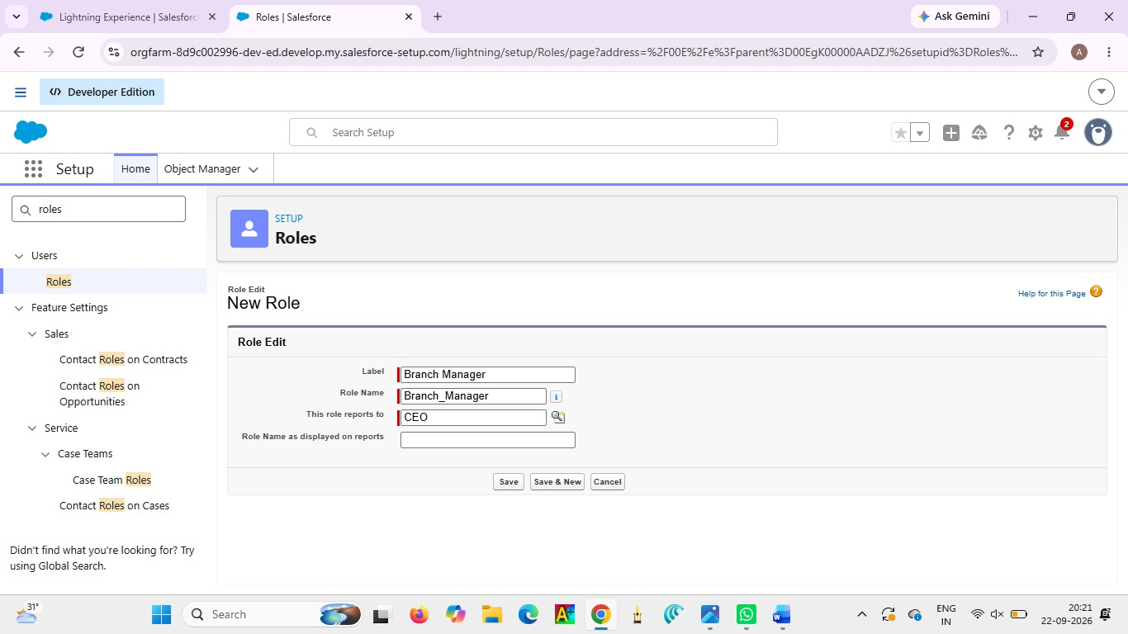

Activity 3: Creating Delivery Agent Role Under Branch Manager Role
Steps: 1.
Below the Branch Manager role, click on Add Role.
2. Enter Label as “Delivery Agent”.
○ Role Name will auto-populate.
3. Click Save.
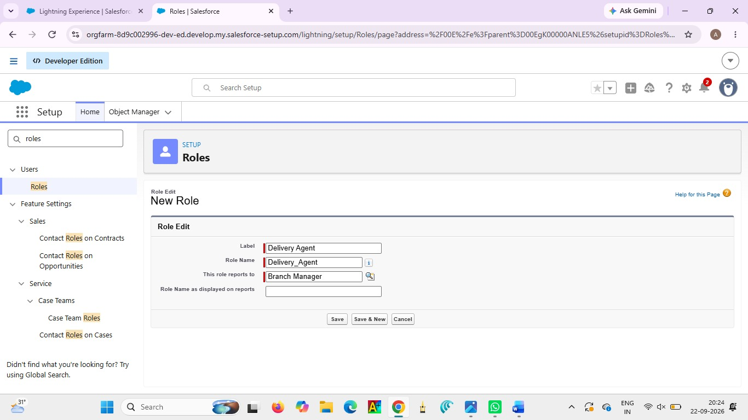

Activity 4: Creating Customer Support Role Under Branch Manager
Steps:
1. Under the Branch Manager role, click on Add Role.
2. Enter Label as “Customer Support”.
3. Role Name will automatically populate.
4. Click Save.
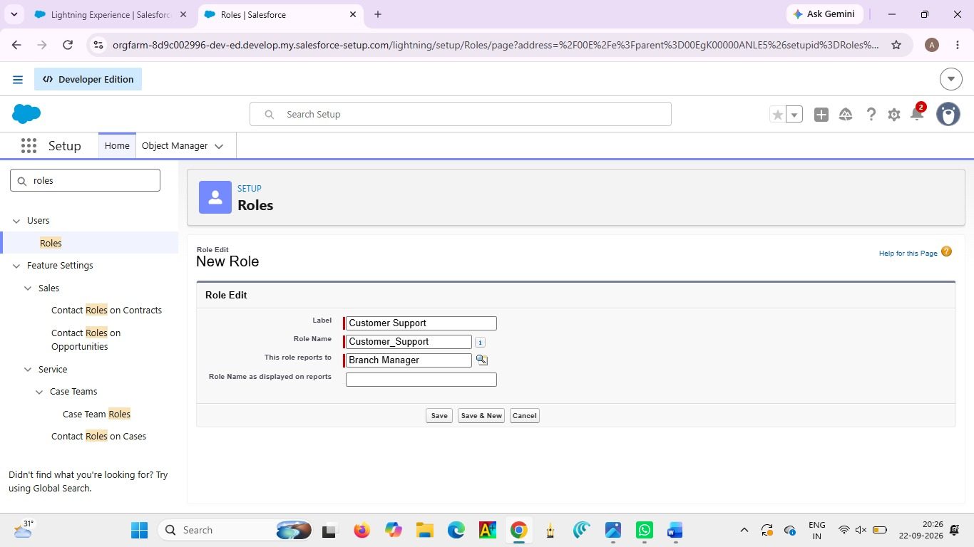

Purpose of This Hierarchy :
● Courier Admin – Highest level access to all data
● Branch Manager – Manages branch-level operations
● Delivery Agent – Access only to assigned shipments
● Customer Support – Limited access to customer and shipment tracking
This hierarchy ensures proper data sharing and security in the Courier Management System.

Milestone 11- User :
What is a user?
A User in Salesforce is a person who has access to the Salesforce system.Each user is assigned a username, profile, and role to manage their access and responsibilities.
NOTE- As Salesforce license can only be used by 2 Users at a time in Dev Org, So If you don’t find a salesforce license then deactivate a user who has a salesforce license Or change the license type from Salesforce to any other.

Activity 1: To Create a User Steps:
1. From Setup, enter Users in the Quick Find box, then select Users.
2. Click New User.
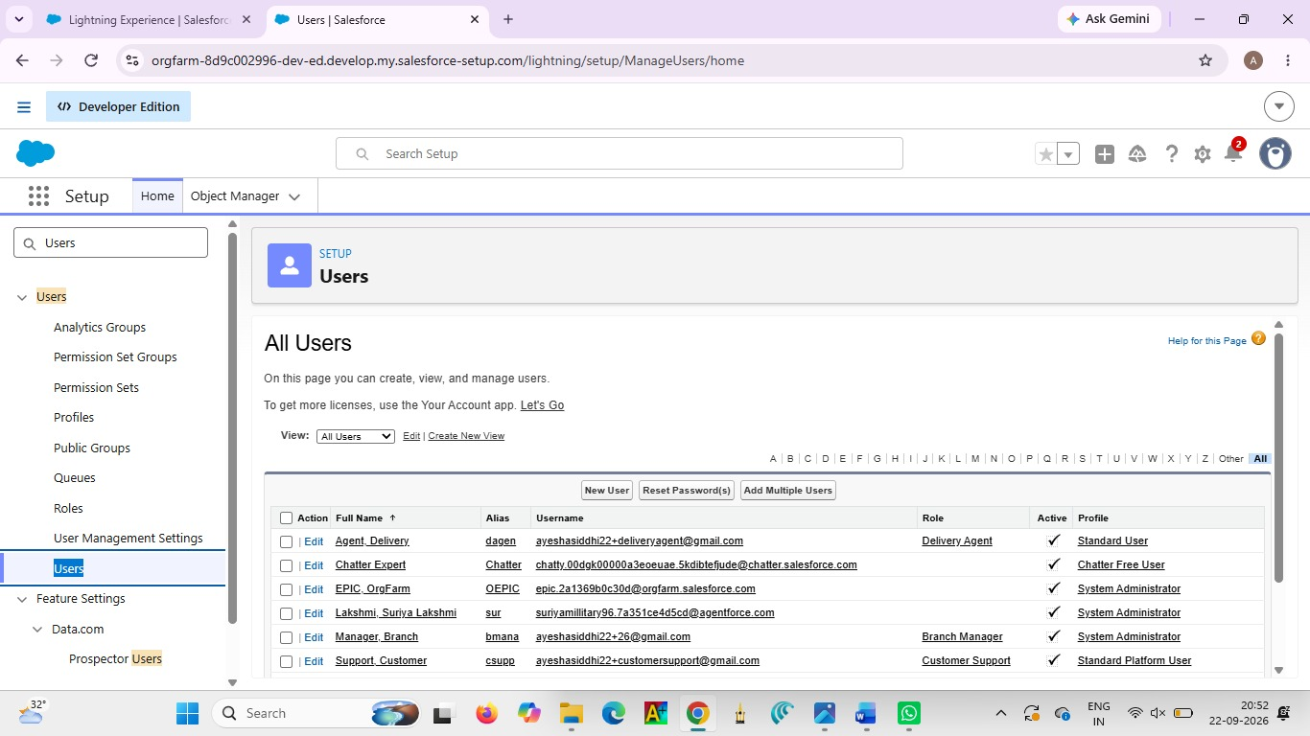

Fill in the Fields:

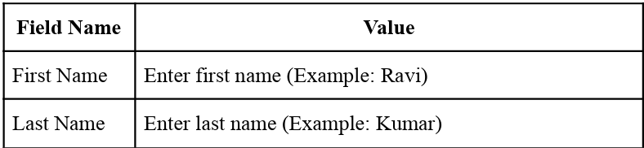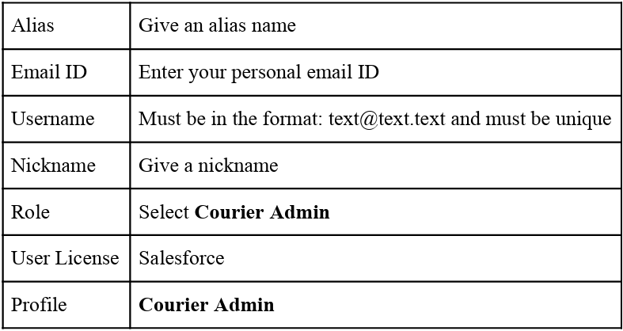

3. Click Save.

Activity 2: Creating Other Users Repeat the same steps as
Activity 1 for creating additional users.
Use the following details:
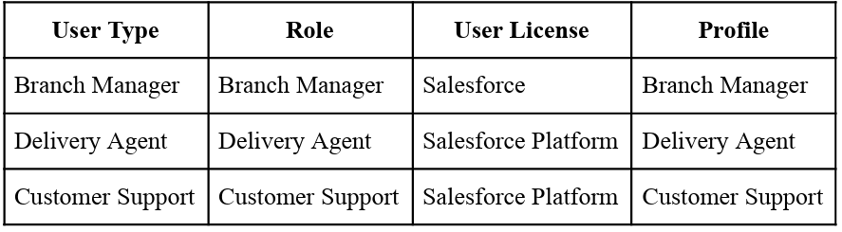

Example:
To create a Branch Manager User:
● Go to Setup → Users → New User
● Fill details like:
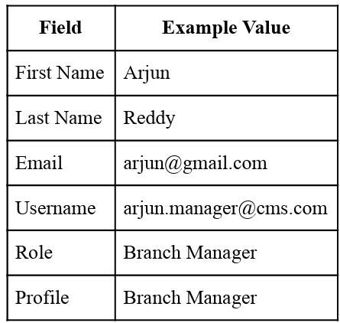
● Click Save
To Create Delivery Agent User: Follow same steps with:
● Role: Delivery Agent
● Profile: Delivery Agent
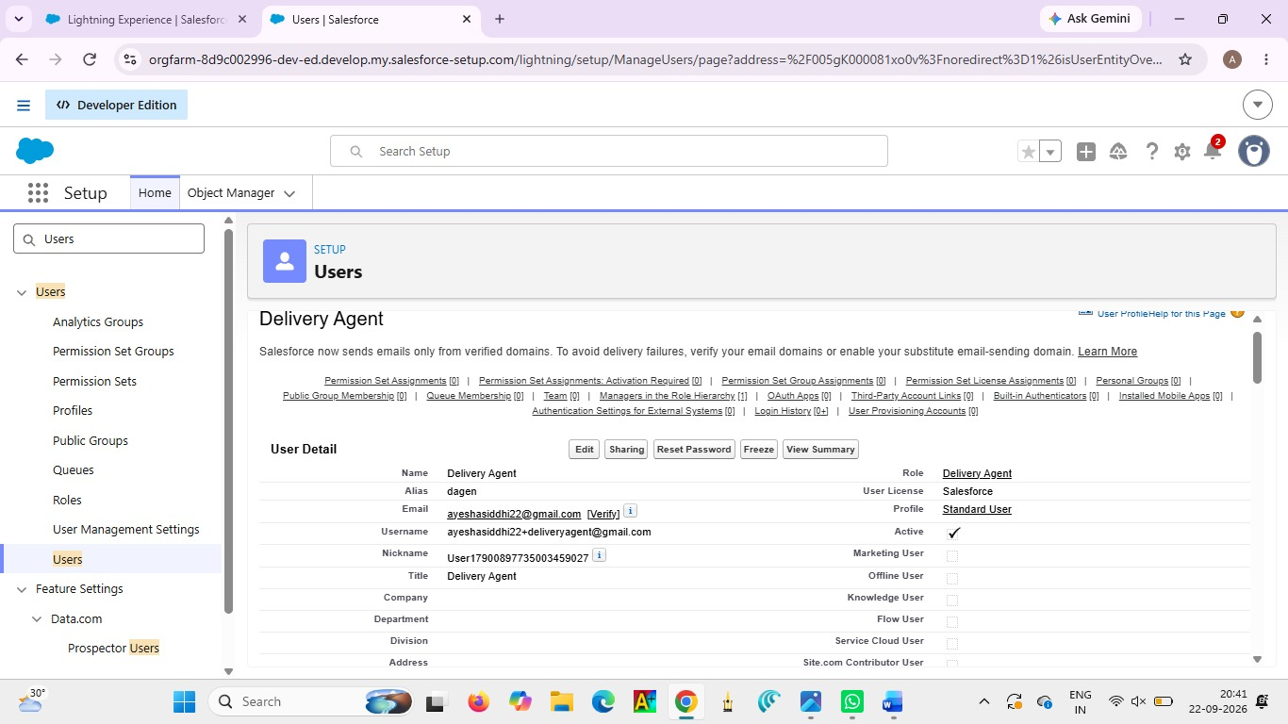

To Create Customer Support User:
● Role: Customer Support
● Profile: Customer Support
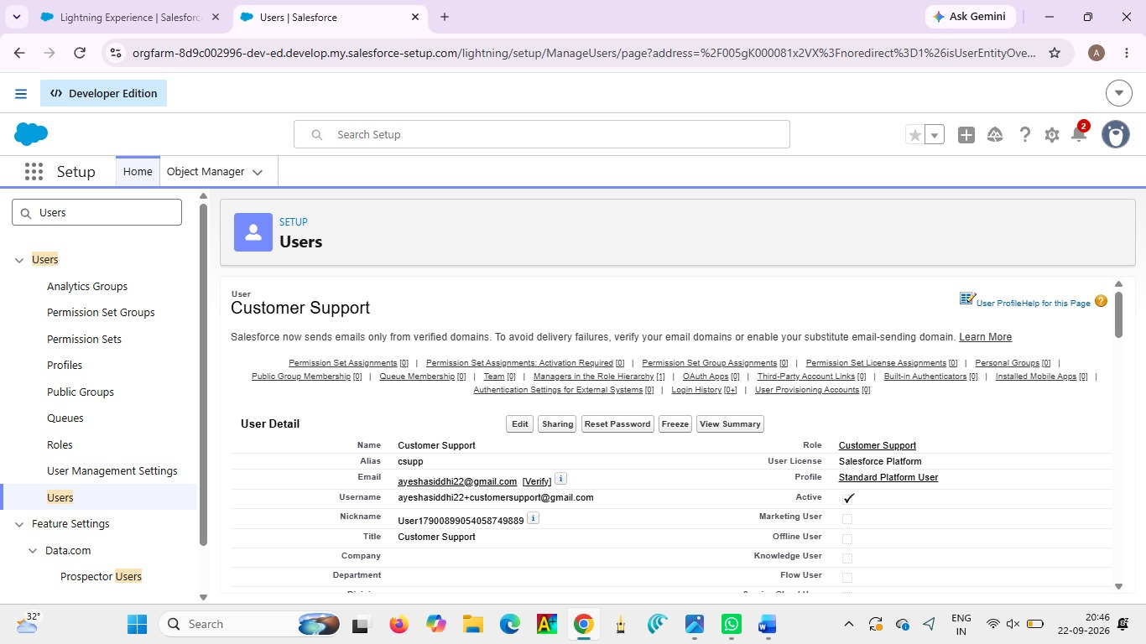

Important Points
Every user must have:
○ Unique username
○ Valid email
○ Assigned Role
○ Assigned Profile
● Profiles control permissions
● Roles control data visibility

Milestone 15 :
Reports & Dashboards Reports and Dashboards help analyze business data and track courier operations efficiently.

Activity 1: Create Report Types
Step 1: Open Report Types
1. Click Gear Icon → Select Setup.
2. In Quick Find search Report Types.
3. Click New Custom Report Type.

Step 2: Create Shipment Report Type
● Primary Object: Shipment__c
● Label: Shipment Tracking Report
● Category: Reports
● Deployment Status: Deployed
● Click Next → Save

Step 3: Create Customer Report Type
● Primary Object: Customer__c
● Label: Customer Summary Report
● Category: Reports
● Deployment Status: Deployed
● Click Next → Save
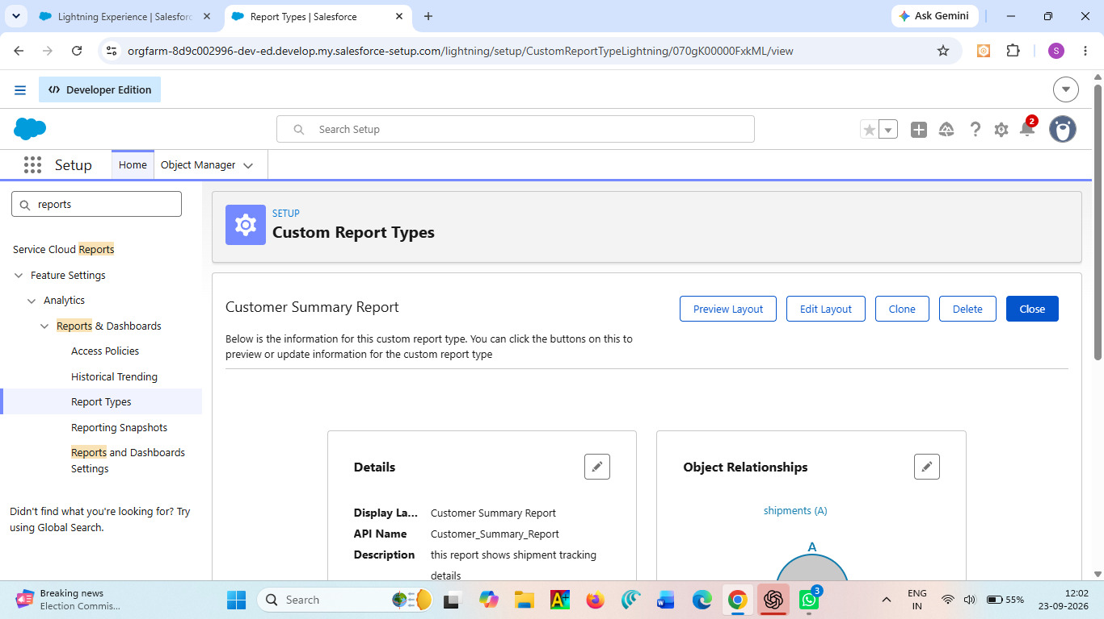

Step 4: Create Agent Performance Report Type
● Primary Object: Delivery_Agent__c
● Label: Agent Performance Report
● Category: Reports
● Deployment Status: Deployed
● Click Next → Save

Activity 2: Create Reports Report
1: Shipment Status Summary Report Step
1: Create the Report
1. Click App Launcher (9 dots) → Search Reports
2. Click New Report
3. Choose Shipment Tracking Report
4. Click Continue

Step 2: Add Columns Add these fields:
● Tracking Number
● Customer
● Status
● Expected Date
● Assigned Agent
Step 3: Add Filters
● Show Me: All Shipments
● Date Filter: This Month
● Status Filter: Select specific Status (Optional)

Step 4: Group & Summarize
● Group rows by Status__c
● Add summary on Price

Step 5: Save Report
● Click Save & Run
● Name: Shipment Status Summary
● Folder: CMS Reports

Report 2: Agent Performance Report
Step 1: Create Report
● New Report → Choose Agent Performance Report
● Click Continue

Step 2: Add Columns
● Agent Name
● Branch
● Number of Shipments
● Status
Step 3: Group Data
● Group by Delivery_Agent__c

Step 4: Save Report
● Name: Agent Performance Report
● Folder: CMS Reports
● Save & Run

Report 3: Revenue Report
Steps:
● Create report using Shipment Tracking Report Type
Add fields:
● Tracking Number
● Customer
● Price
● Invoice Status
Group by:
● Branch
● Month
Save as: Revenue by Branch Report
Activity 3: Create Dashboard
Step 1: Open Dashboards
1. Click App Launcher (9 dots)
2. Search Dashboards
3. Click New Dashboard

Step 2: Enter Dashboard Details
● Name: Courier Management Dashboard
● Folder: CMS Reports
● Click Create

Activity 4: Add Dashboard Components Component
1: Shipment Status Overview (Donut Chart)
1. Click + Component
2. Choose report: Shipment Status Summary
3. Visual Type: Donut Chart
4. Click Add

Component 2: Agent Performance (Bar Chart)
● Select report: Agent Performance Report
● Chart Type: Bar Chart
● Click Add

Component 3: Revenue by Branch (Column Chart)
● Choose report: Revenue by Branch Report
● Chart Type: Column Chart
● Click Add

Activity 5: Save & Activate Dashboard
1. Click Save
2. Click Done

Share Dashboard With:
● Courier Admin
● Branch Managers
● Customer Support Team
Final Layout :
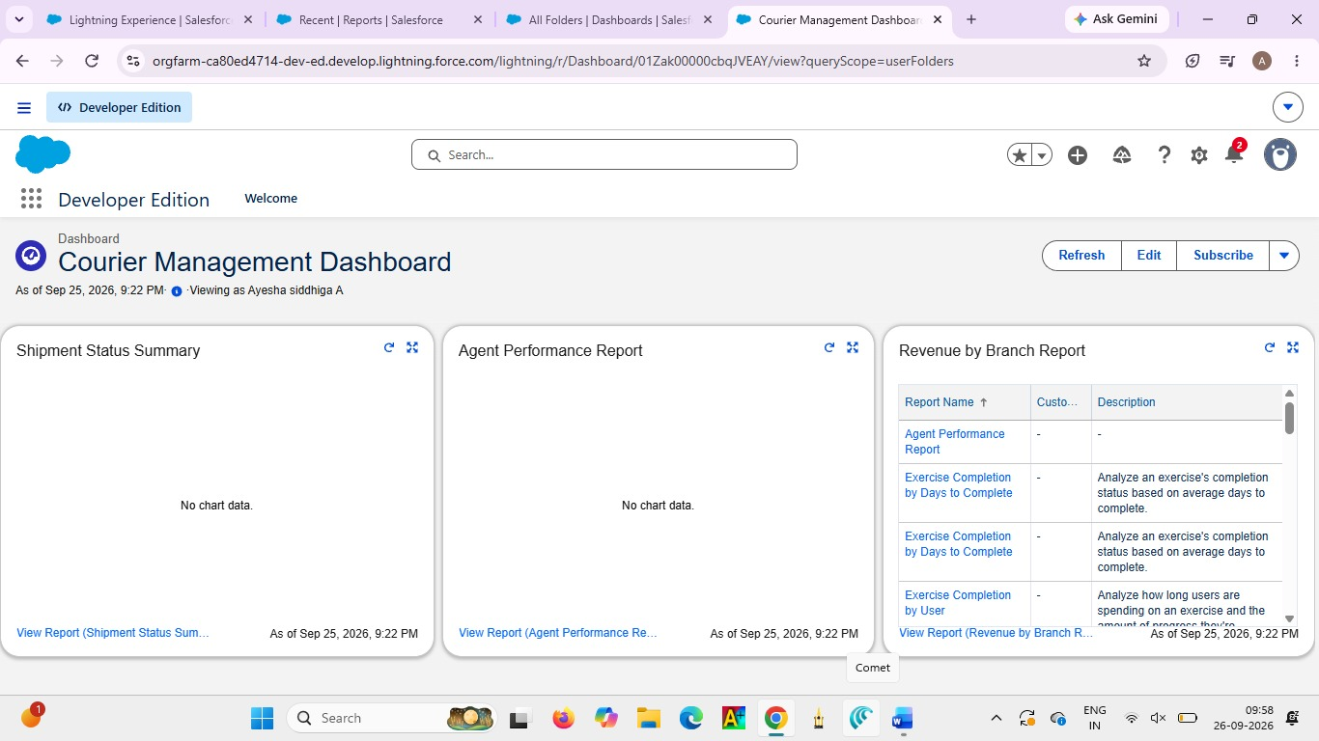

7. FUNCTIONAL & PERFORMANCE TESTING
The system is tested to ensure that all courier functions work correctly.Customer, Shipment, Delivery Agent, Branch, and Invoice records are checked.Validation Rules and Flows are tested for accurate data and proper automation.Reports and Dashboards are tested to ensure that the required information is displayed correctly.

8. ADVANTAGES & DISADVANTAGES
Advantages
- Centralized management of customer and shipment data.

- Reduces errors using Validation Rules.

- Automates shipment updates using Flows.

- Provides easy monitoring through Reports and Dashboards.

- Supports organized management of courier operations.

Disadvantages

• Requires internet access to use Salesforce.

• Initial setup and configuration may take time.

• Users need basic Salesforce knowledge.

9. Conclusion:
The Courier Management System successfully digitizes courier operations using Salesforce automation, improving efficiency, accuracy, and customer satisfaction.

10. FUTURE SCOPE
● Mobile tracking app
● GPS integration
● SMS notifications
● AI-based delivery optimization

11. APPENDIX
● Source Code: Salesforce Configuration
● Dataset: Salesforce Objects
● GitHub / Demo: Salesforce Developer Org

Thank You

